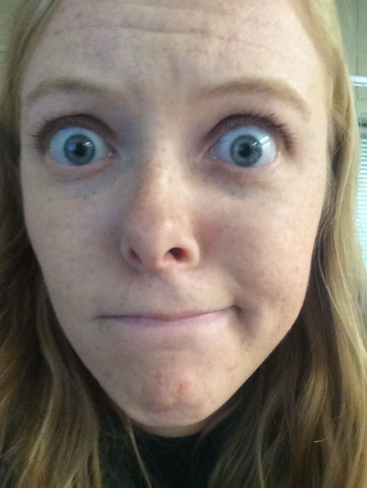
Ms. Vockrodt by the Numbers
0 pets

4th year teaching

7.25 years since I graduated from Riggs

1 brother

46 days until I get married

3 jobs other than teaching

8 countries visited

15 years of dance lessons

Yes, this is me on the first day of my freshman year of high school!
≈1,000,000 stickers in my desk drawer
18 years in music

Your Assignment:

- Create your own!
- Requirements:
- Write 10 things about yourself using numbers (they can be any numbers!)
- Make sure the information helps me get to know you better.
- Include at least one picture of yourself.
- You can do this assignment in Word, Publisher, or another program of your choice, OR you can do it without technology by writing/drawing.
- Turn in a paper copy or you may email it to me. (megan.vockrodt@k12.sd.us)
- Due Friday, August 24th by the beginning of your class period.

