9.1 Solid Figures
Goal: Identify and name solid figures.
Solid: _____________________________________ shapes
Polyhedron: a solid formed by _______________________.
Faces: the plane ___________________ of a polyhedron.
Edges: the _______________ joining the vertices of a polyhedron.
Bases: the top and/or bottom planes of a figure. A prism has _____ bases. A pyramid has _____ base.

Tell whether the solid is a polyhedron. Then name the solid and find the number of faces, vertices, and edges.
a) Polyhedron? _________ b) Polyhedron? _________ c) Polyhedron? _________
Name: ________________________ Name: ________________________ Name: _______________________
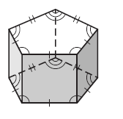
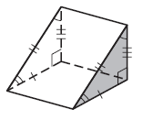
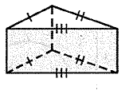
F: ______ V: ______ E: ______ F: ______ V: ______ E: ______ F: ______ V: ______ E: ______

d) Polyhedron? _________ e) Polyhedron? _________ f) Polyhedron? _________
Name: ________________________ Name: ________________________ Name: _______________________
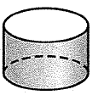
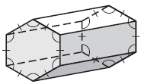
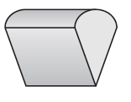
F: ______ V: ______ E: ______ F: ______ V: ______ E: ______ F: ______ V: ______ E: ______

g) Polyhedron? _________ h) Polyhedron? _________ i) Polyhedron? _________
Name: ________________________ Name: ________________________ Name: _______________________
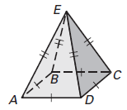
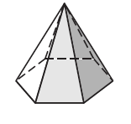
F: ______ V: ______ E: ______ F: ______ V: ______ E: ______ F: ______ V: ______ E: ______
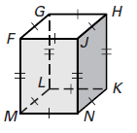

Sketch each figure.
a) a rectangular prism b) a triangular prism c) cylinder

d) cone e) a rectangular pyramid f) a pentagonal pyramid

Euler’s Formula
F + V = E + 2

Use Euler’s Formula to find the number of faces, edges, or vertices.
a) A pyramid has 9 faces and 9 vertices. How many edges does it have?

b) A prism has 8 faces and 18 edges. How many vertices does it have?

c) A polyhedron has 15 edges and 7 vertices. How many faces does it have?

9.2 Surface Area of Prisms and Cylinders
Goal: Find the surface areas of prisms and cylinders.
Prism: a polyhedron with two congruent ___________ that lie in parallel planes
Surface area: on a polyhedron, the sum of the _____________ of its faces
Cylinder: a solid with two congruent _________________ bases that lie in parallel planes
*Note: Surface area is always labeled ________________________
Surface Area of a Prism | Surface Area of a Cylinder
$$SA = 2B + Ph$$ | $$SA = 2πr^{2}+ 2πrh$$
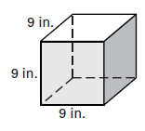
Find the surface area of each figure
a) Shape of base: ____________________
Area of Base (B): ____________________
Perimeter of Base (P): ________________
Height of shape (h): __________________
Surface Area: _______________________

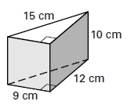
b) Shape of base: ____________________
Area of Base (B): ____________________
Perimeter of Base (P): ________________
Height of shape (h): __________________
Surface Area: _______________________

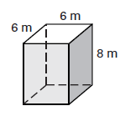
c) Shape of base: ____________________
Area of Base (B): ____________________
Perimeter of Base (P): ________________
Height of shape (h): __________________
Surface Area: _______________________

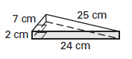
d) Shape of base: ____________________
Area of Base (B): ____________________
Perimeter of Base (P): ________________
Height of shape (h): __________________
Surface Area: _______________________

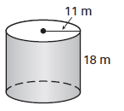
e) Shape of base: ____________________
Area of Base (B): ____________________
Circumference of Base (P): ________________
Height of shape (h): __________________
Surface Area: _______________________

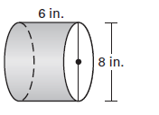
f) Shape of base: ____________________
Area of Base (B): ____________________
Circumference of Base (P): ________________
Height of shape (h): __________________
Surface Area: _______________________
9.3 Surface Area of Pyramids and Cones – Day 1
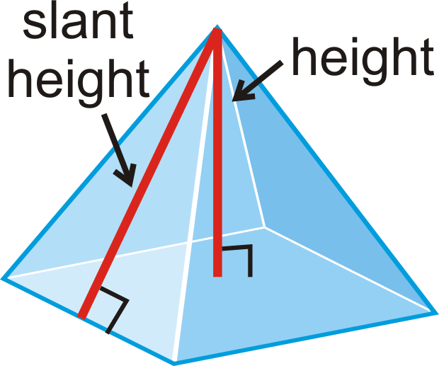
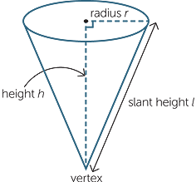
Goal: Find the surface area of pyramids and cones.

Surface Area of a Pyramid | Surface Area of a Cone
$$SA = B +\frac{1}{2}Pl$$ | $$SA =πr^{2}+ πrl$$
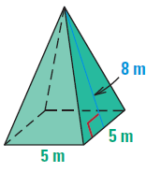
Find the surface area of each figure.
a) Shape of the base: _______________________
Area of the base (B): ________________________
Perimeter of the base (P): ____________________
Slant height (l): ____________________________
Surface Area: ______________________________

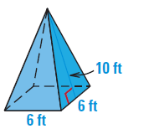

b) Shape of the base: _______________________
Area of the base (B): ________________________
Perimeter of the base (P): ____________________
Slant height (l): ____________________________
Surface Area: ______________________________

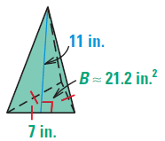
c) Shape of the base: _______________________
Area of the base (B): ________________________
Perimeter of the base (P): ____________________
Slant height (l): ____________________________
Surface Area: ______________________________

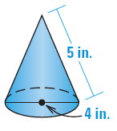
d) Shape of the base: _____________________
Radius (r): ______________________________
Area of the base ($πr^{2})$: ___________________
Slant height (l): __________________________
Surface Area: ___________________________

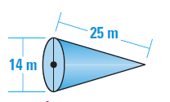
e) Shape of the base: _____________________
Radius (r): ______________________________
Area of the base ($πr^{2})$: ___________________
Slant height (l): __________________________
Surface Area: ___________________________

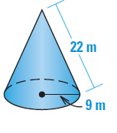
f) Shape of the base: _____________________
Radius (r): ______________________________
Area of the base ($πr^{2})$: ___________________
Slant height (l): __________________________
Surface Area: ___________________________
9.3 Surface Area of Pyramids and Cones – Day 2
Goal: Find the surface area of pyramids and cones.

*If the slant height of a cone or pyramid is not given, you just first use the _________________________________ to find it.

Surface Area of a Pyramid | Surface Area of a Cone
$$SA = B +\frac{1}{2}Pl$$ | $$SA =πr^{2}+ πrl$$

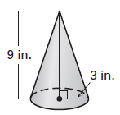
Find the surface area of each figure.
a) Shape of the base: _____________________
Radius (r): ______________________________
Area of the base ($πr^{2})$: ___________________
Slant height (l): __________________________
Surface Area: ___________________________

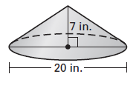
b) Shape of the base: _____________________
Radius (r): ______________________________
Area of the base ($πr^{2})$: ___________________
Slant height (l): __________________________
Surface Area: ___________________________

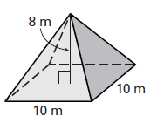
c) Shape of the base: _______________________
Area of the base (B): ________________________
Perimeter of the base (P): ____________________
Slant height (l): ____________________________
Surface Area: ______________________________

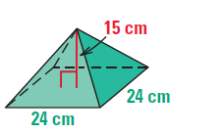
d) Shape of the base: _______________________
Area of the base (B): ________________________
Perimeter of the base (P): ____________________
Slant height (l): ____________________________
Surface Area: ______________________________

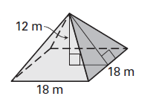
e) Shape of the base: _______________________
Area of the base (B): ________________________
Perimeter of the base (P): ____________________
Slant height (l): ____________________________
Surface Area: ______________________________

9.4 Volume of Prisms and Cylinders
Goal: Find the volumes of prisms and cylinders.
Volume: the number of ___________________________ units contained in a solids interior.
*Note: Volume is always labeled ____________________________
Volume of a Prism | Volume of a Cylinder
$$V = Bh$$ | $$V=πr^{2}h$$
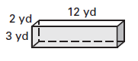
Find the volume of each solid.
a) Shape of the base: __________________
Area of the base (B): __________________
Height (h): __________________________
Volume: ____________________________

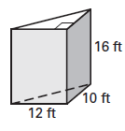
b) Shape of the base: __________________
Area of the base (B): __________________
Height (h): __________________________
Volume: ____________________________

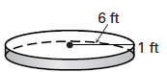
c) Shape of the base: _________________
Area of the base ($πr^{2}$): ________________
Height (h): __________________________
Volume: ____________________________

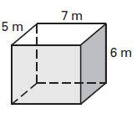
d) Shape of the base: __________________
Area of the base (B): __________________
Height (h): __________________________
Volume: ____________________________

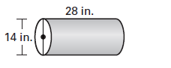
e) Shape of the base: _________________
Area of the base ($πr^{2}$): ________________
Height (h): __________________________
Volume: ____________________________

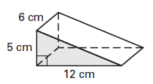
f) Shape of the base: __________________
Area of the base (B): __________________
Height (h): __________________________
Volume: ____________________________

9.5 Volume of Pyramids and Cones
Goal: Find the volumes of pyramids and cones.
Volume of a Pyramid | Volume of a Cone
$$V=\frac{1}{3}Bh$$ | $$V=\frac{1}{3}πr^{2}h$$
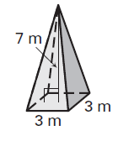
Find the volume of each figure.
a) Shape of the base: __________________
Area of the base (B): __________________
Height (h): __________________________
Volume: ____________________________

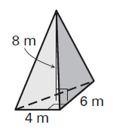
b) Shape of the base: __________________
Area of the base (B): __________________
Height (h): __________________________
Volume: ____________________________

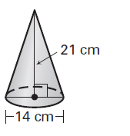
c) Shape of the base: __________________
Area of the base ($πr^{2}$): ________________
Height (h): __________________________
Volume: ____________________________

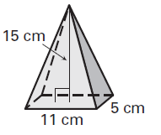
d) Shape of the base: __________________
Area of the base (B): __________________
Height (h): __________________________
Volume: ____________________________

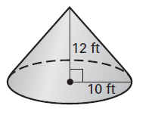
e) Shape of the base: __________________
Area of the base ($πr^{2}$): ________________
Height: _____________________________
Volume: ____________________________

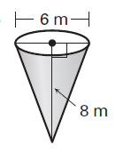
f) Shape of the base: __________________
Area of the base ($πr^{2}$): ________________
Height: _____________________________
Volume: ____________________________

9.5 Volume of Pyramids and Cones – Day 2
Goal: Find the volumes of pyramids and cones.
*If the height of a cone or pyramid is not given, you just first use the ______________________________ to find it.
Volume of a Pyramid | Volume of a Cone
$$V=\frac{1}{3}Bh$$ | $$V=\frac{1}{3}πr^{2}h$$
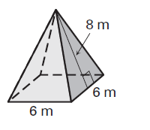
Find the volume of each figure.
a) Shape of the base: __________________
Area of the base (B): __________________
Height (h): __________________________
Volume: ____________________________

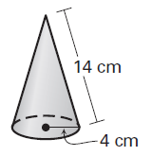

b) Shape of the base: __________________
Area of the base ($πr^{2}$): ________________
Height (h): __________________________
Volume: ____________________________

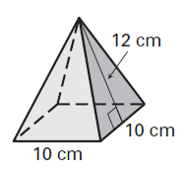
c) Shape of the base: __________________
Area of the base (B): __________________
Height (h): __________________________
Volume: ____________________________

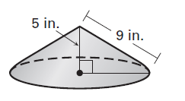
d) Shape of the base: __________________
Area of the base ($πr^{2}$): ________________
Height (h): __________________________
Volume: ____________________________

9.6 Surface Area and Volume of Spheres
Goal: Find the surface area and volume of spheres.
Surface Area of a Sphere | Volume of a Sphere | Volume of a Hemisphere
$$SA=4πr^{2}$$ | $$V=\frac{4}{3}πr^{3}$$ | $$V=\frac{2}{3}πr^{3}$$
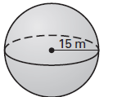
Find the surface area of each sphere.
a) Radius: ___________________
Radius squared (r²): ___________
Surface Area: ________________

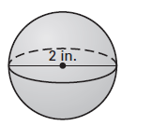
b) Radius: ___________________
Radius squared (r²): ___________
Surface Area: ________________

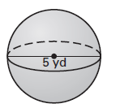
c) Radius: ___________________
Radius squared (r²): ___________
Surface Area: ________________

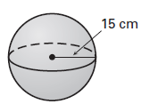
Find the volume of each sphere or hemisphere.
a) Radius: ___________________
Radius cubed (r³): ____________
Volume: ____________________

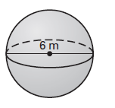
b) Radius: ___________________
Radius cubed (r³): ____________
Volume: ____________________

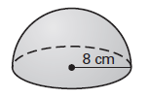
c) Radius: ___________________
Radius cubed (r³): ____________
Volume: ____________________

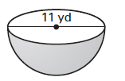
d) Radius: ___________________
Radius cubed (r³): ____________
Volume: ____________________

