4.1 Classifying Triangles
Goal: Classify triangles by their sides and by their measures.
Triangle: a figure formed by three _________________ joining three noncolinear _________________
Vertex: a point that joins two ____________ of the triangle
Classification of Triangles by Sides
Equilateral  _______ congruent sides |  | Isosceles  _______ congruent sides |  | Scalene  _______ congruent sides
Classification of Triangles by Angles
Equiangular  _____ congruent angles | Acute  _____ acute angles |  | Right  _____ right angle |  | Obtuse  _____ obtuse angle

Classify each triangle by its sides.
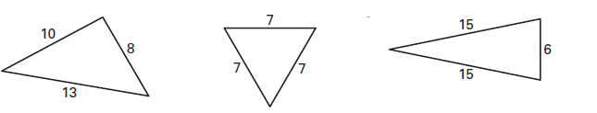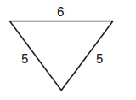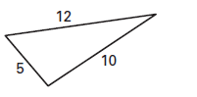

Classify the triangle by its angles.
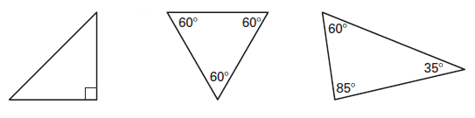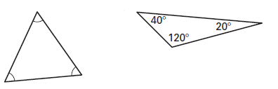
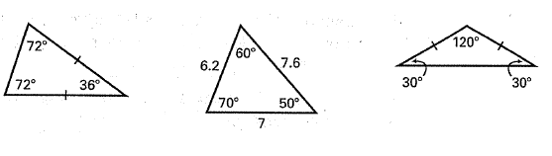
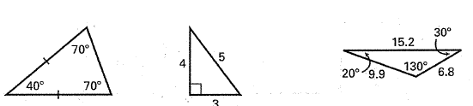
Classify each triangle by its angles AND sides.

Determine if a triangle can be both classifications. If possible, draw the type of triangle.
Obtuse and scalene? Right and isosceles?

Equilateral and acute? Right and acute?

Scalene and isosceles? Obtuse and equilateral?

Obtuse and isosceles? Scalene and acute?

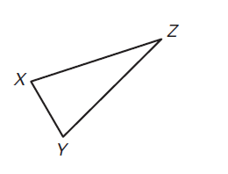
Identify which side is opposite each angle.

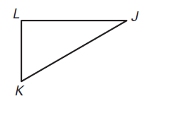

4.2 Angle Measures of Triangles
Goal: Find interior and exterior angle measures in triangles.
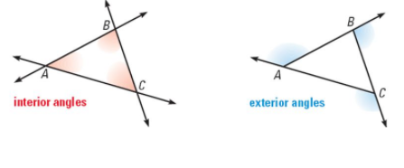
Interior Angles: when the sides of a triangle are extended, the three original angles are the interior angles.
Exterior Angles: when the sides of a triangle are extended, the angles that are adjacent to the interior angles are the exterior angles.
Triangle Sum Theorem: The sum of the measures of the angles of a triangle is ____________ | 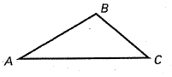  _________ + _________ + _________ = _________
Find the measure of $∠1$.
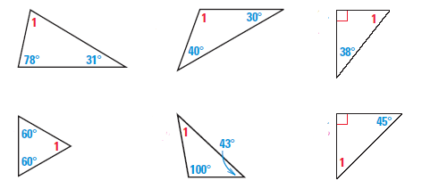
a) ________ b) ________ c) ________

d) ________ e) ________ f) ________

Find the value of x. Then find the measure of each angle.
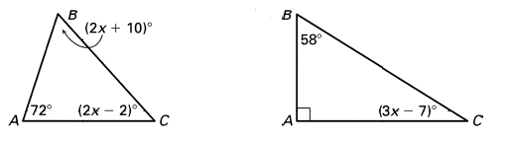
a) x = ________ b) x = ________

Exterior Angle Theorem: the measure of an exterior angle of a triangle is equal to the ________ of the measures of the two nonadjacent _______________________ angles | 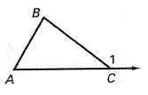  ________ = ________ + ________

Find the measure of each missing angle.
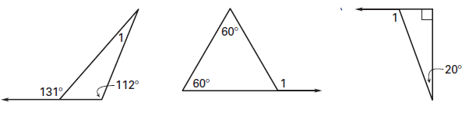
a) ________ b) ________ c) ________

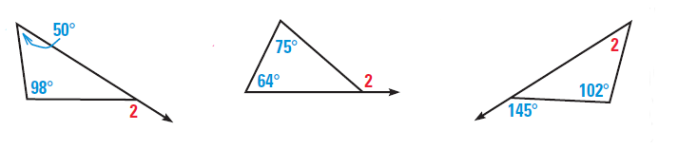
d) ________ e) ________ f) ________

Find the value of x.
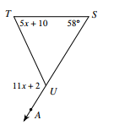
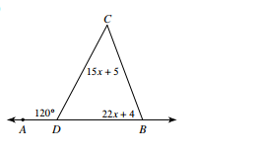
a) x = _______ b) x = ______

4.3 Isosceles and Equilateral Triangles
Goal: Use properties of isosceles and equilateral triangles to find side lengths and angle measures.
Isosceles Triangle Vocabulary
Legs: the __________________ sides
Base: the side that is not ________________
Base angles: the two angles at the ________________
Base Angles Theorem: If two sides of a triangle are congruent, then the angles __________________ of them are ___________________ | 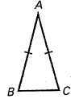  If $\overline{AB}≅\overline{AC}$, then  ______ $≅$ ______
Converse of the Base Angles Theorem: If two ______________ are congruent, then the sides __________________ of them are congruent | 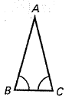  If $∠B≅∠C$, then  ______ $≅$ ______

Find the value of x. If x is an angle, also find the measure of each angle.
a) x = __________ b) x = __________ c) x = __________
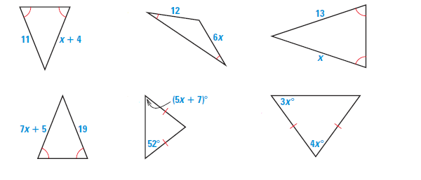

d) x = __________ e) x = __________ f) x = __________

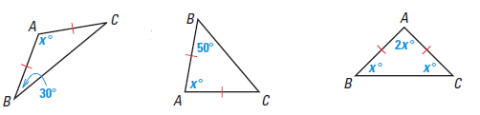
g) x = __________ h) x = __________ i) x = __________

Equilateral Theorem: If a triangle is equilateral, then it is ___________________ | 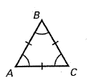  If $\overline{AB}≅\overline{AC}≅\overline{BC}$,  then _____ $≅$ _____ $≅$ ______
Equiangular Theorem: If a triangle is equiangular, then it is ___________________ | If $∠A≅∠B≅∠C$,  then _____ $≅$ _____ $≅$ ______

**Each angle in an equiangular triangle will always be ___________

Find the value of each variable.
a) x = __________ b) x = __________ c) x = __________
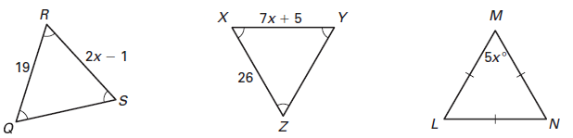

d) y = __________ e) y = __________ f) x = ______ y = _______
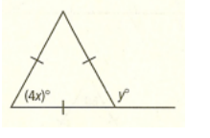
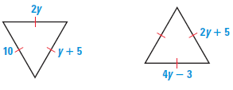

4.4 Part A: The Distance Formula
Goal: Find the distance between two coordinates.
The Distance Formula
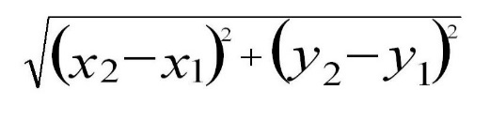  For any two coordinates $A(x_{1}, y_{1})$ and $B(x_{2}, y_{2})$, the distance between A and B is written AB and is | Step 1: __________ in the coordinates  Step 2: Simplify _____________________  Step 3: _______________ each parenthesis. Remember! Squaring a negative number makes it positive.  Step 4: ___________ together the two numbers  Step 5: Simplify the _____________________

Why will your answer never be a negative number?

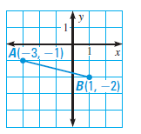
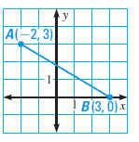
Find the distance between each pair of coordinates.
a) _________________ b) __________________

c) _________________ $C\left(-3, -4\right) and D(-2, 5)$ d) ___________________$E\left(0, -4\right) and F(4, 0)$

e) _________________ $G\left(-8, 10\right) and H(-2, 7)$ f) __________________ $I\left(11, 13\right) and J(-1, -5)$

4.4 Part B: The Pythagorean Theorem
Goal: Use the Pythagorean Theorem to find missing sides of right triangles.
Legs of a right triangle: the sides that form the ______________________________
Hypotenuse: the side ___________________ of the right angle
The Pythagorean Theorem
In a right triangle, the square of the _______________________ is equal to the sum of the squares of the lengths of the ______________ | ________ + ________ = ________

Use the Pythagorean theorem to find each missing side length. If necessary, round to the nearest tenth.
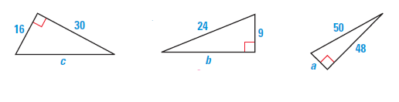
a) c = _____________ b) b = _____________ c) a = ____________

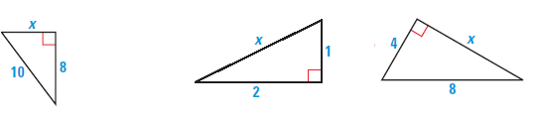
d) x = _____________ e) x = _____________ f) x = ____________

Pythagorean triple: a set of three positive integers a, b, and c that satisfy the equation $a^{2}+b^{2}=c^{2}$.

Tell whether the given side lengths form a Pythagorean triple.
a) 8, 10, 6 b) 7, 8, 9 c) 14, 50, 48

Draw and label a picture of the situation, then use the Pythagorean Theorem to solve.
a) To hang lights on her house, Ms. Blaseg placed a 15 foot ladder 3 feet from the base of her house. How high up the house will the ladder reach?

b) Steve is turning half of his backyard into a chicken pen. His backyard is a 24 meter by 45 meter rectangle. He wants to put a chicken wire fence that stretches diagonally from one corner to the opposite corner. How many meters of fencing will Steve need?

c) A ship leaves port and travels 100 km east then turns south and travels 75 km. How far from the port is the ship?

d) A wire is stretched from the top of a 12 foot pole to a stake 5 feet from the base of the pole. How long is the wire?

4.5 The Converse of the Pythagorean Theorem
Goal: Use side lengths to determine whether triangles are acute, obtuse, or right.
Classifying Triangles Using the Converse of the Pythagorean Theorem
In $∆ABC$ with longest side C….
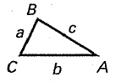  If ______ ______ + ______  then the triangle is acute. | 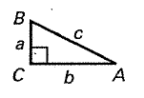  If ______ ______ + ______  then the triangle is right. | 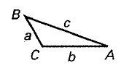  If ______ ______ + ______  then the triangle is obtuse.

Classify the triangle with the given side lengths as acute, right, or obtuse.
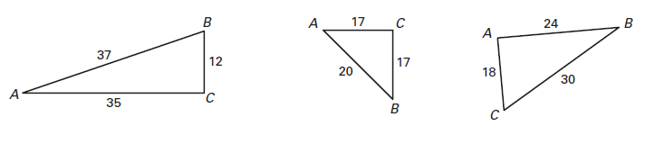
a) ____________________ b) ______________________ c) ____________________

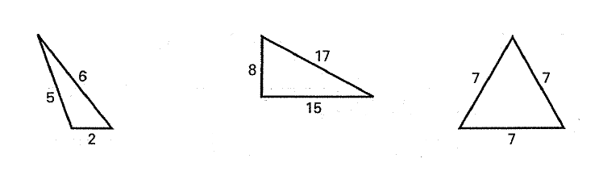
d) ____________________ e) ______________________ f) ____________________

g) ____________________ h) ______________________ i) ____________________
$1, 8, \sqrt{65}$ $\sqrt{33}, 9, 7$ $4, 9, \sqrt{104}$

4.6 Medians of Triangles
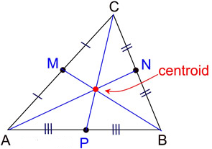
Goal: Draw medians and centroids. Use properties of medians to find missing lengths.
Median: a segment from the vertex to the ____________________ of the opposite side.
Centroid: the point at with the medians of the triangle _____________________
Use a ruler to draw all three medians in each triangle. Label the centroid of each triangle X.
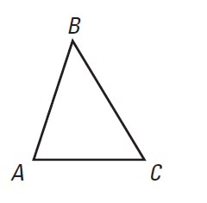

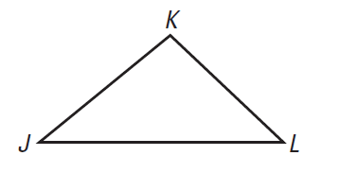

Intersections of Medians of a Triangle
The medians of a triangle intersect at a point that is _______________________ of the distance from each vertex to the midpoint of the opposite side. | 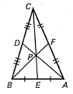  If $P$ is the centroid of $∆ABC$, then  $AP=\frac{2}{3}____$ and $BP=\frac{2}{3}____$  and $CP=\frac{2}{3}____$

P is the centroid of $∆LMN$. Find QP and PN.
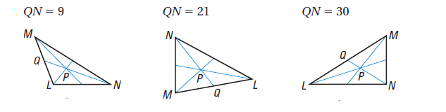
a) QP = ______ PN = _______ b) QP = ______ PN = _______ c) QP = ______ PN = _______

D is the centroid of $∆ABC$. Find CD and CE.
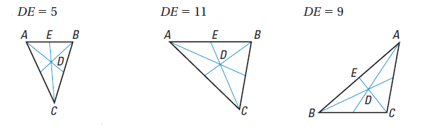
a) CD = ______ CE = _______ b) CD = ______ CE = _______ c) CD = ______ CE = _______

P is the centroid of each triangle. Use the information given to find the lengths.
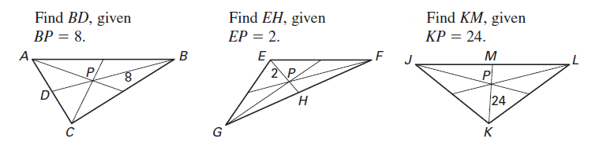
a) BD = _________ b) EH = _________ c) KM = _______

AngLegs – Is it a Triangle?
4.7 Investigation
Determine if a triangle can be made with the following colors as sides. List the side length of each color and whether or not it makes a triangle.
Orange: 5 cm Purple: 7 cm Green: 9 cm
Yellow: 10 cm Blue: 12 cm Red: 14 cm

Colors of Sides | Length of side 1 | Length of side 2 | Length of side 3 | Did it make a triangle?
1. Purple, purple, orange
2. Orange, green, yellow
3. Green, orange, red
4. Orange, blue, red
5. Orange, purple, orange
6. Blue, orange, purple
7. Orange, orange, blue
8. Purple, orange, yellow
9. Orange, purple, red
10. Green, yellow, blue

Go back and observe the side lengths, find a rule for when the side lengths make a triangle.

Find a rule for when the side lengths do not make a triangle.

4.7 Triangle Inequalities
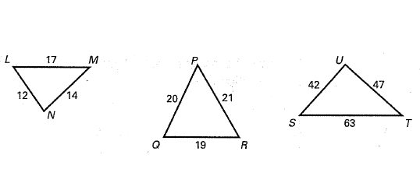
Goal: Use triangle measures to decide which side is the longest and which angle is the largest.
If one side of a triangle is longer than another side, then the angle opposite the longer side is ______________ than the angle opposite the shorter side. | 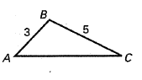  If $BC>AB$, then $m∠$A ______ $m∠C$
If one angle of a triangle is larger than another angle, then the side opposite the larger angle is ______________ than the side opposite the smaller angle. | 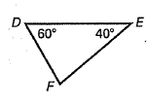  If $m∠D>m∠E$, then $EF _________DF$
Name the angles from largest to smallest.

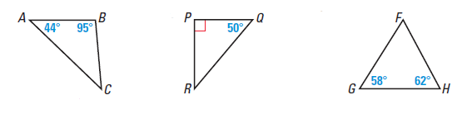
Name the sides from longest to shortest.

Triangle Inequality Theorem: The sum of the lengths of any two sides of a triangle is ________________ than the length of the third side. | 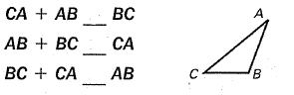
Determine whether the side lengths can form a triangle.
a) 3, 5, 9 b) 7, 5, 12 c) 6, 9, 4

d) 18, 9, 11 e) 20, 36, 13 f) 8.5, 7.2, 3.4

