9.2 Practice A
Exponential Functions
1. If a superball is bounced from a height of 20 feet, the function
f(x) = 20 (0.9)^{x} gives the height of the ball in feet of each bounce,
where x is the bounce number. What will be the height of the
6th bounce? Round your answer to the nearest tenth of a foot. ___________________________
Tell whether each set of ordered pairs satisfies an exponential function. Explain your answer.
2. {(1,10), (2, 20), (3, 40), (4, 80)} __________________________________________________________

3. {(1,5), (2, 10), (3, 15), (4, 20)} __________________________________________________________

Graph each exponential function.
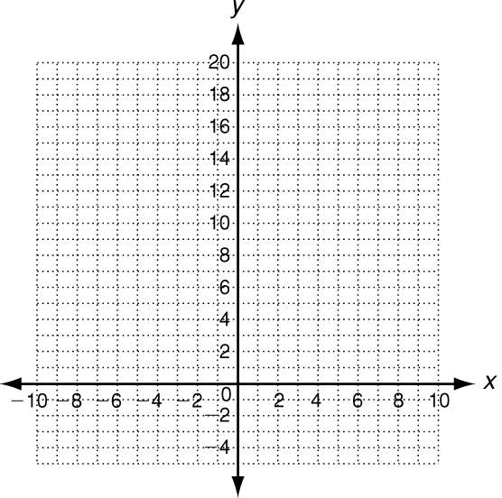
4. y = 2(3)^{x}
x | y = 2 (3)^{x} | y | (x, y)
−2 | y = 2(3)⁻²
−1 | y = 2(3)⁻¹
0 | y = 2(3)⁰
1 | y = 2(3)¹
2 | y = 2(3)²

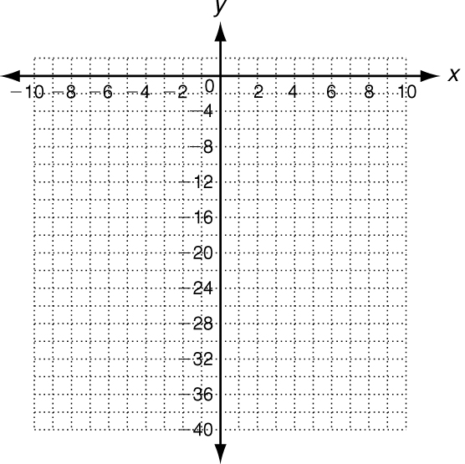
5. y = −2(4)^{x}
x | y = −2 (4)^{x} | y | (x, y)
−2
−1
0
1
2
In the absence of predators, the natural growth rate of rabbits is
4% per year. A population begins with 100 rabbits. The function
f(x) = 100(1.04)^{x} gives the population of rabbits in x years.
6. How long will it take the population of rabbits to double? ___________________________
7. How long will it take the population of rabbits to reach 1000? ___________________________

9.2 Practice B
Exponential Functions
1. If a basketball is bounced from a height of 15 feet, the function
f(x) = 15 (0.75)^{x} gives the height of the ball in feet of each bounce,
where x is the bounce number. What will be the height of the
5th bounce? Round to the nearest tenth of a foot.
_____________________________________
Tell whether each set of ordered pairs satisfies an exponential function. Explain your answer.
2. {(2, 4), (4, 8), (6, 16), (8, 32)} __________________________________________________________

3. {(−2, 5), (−1, 10), (0, 15), (1, 20)} _______________________________________________________

4. {(1, 750), (2, 150), (3, 30), (4, 6)} _______________________________________________________

5. 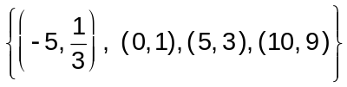 _______________________________________________________

Graph each exponential function.
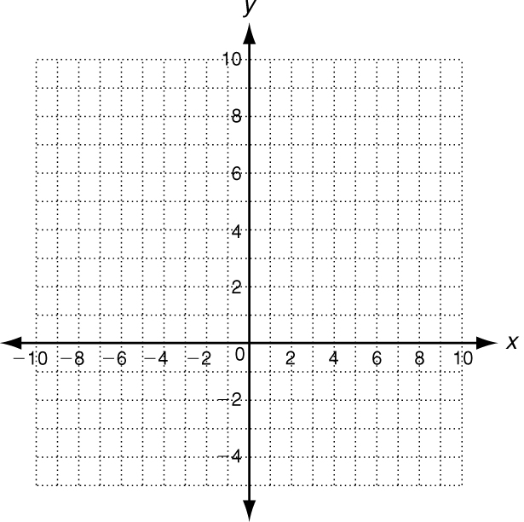
6. y = 5(2)^{x} 7. y = −2(3)^{x} 8. y = 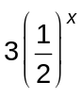
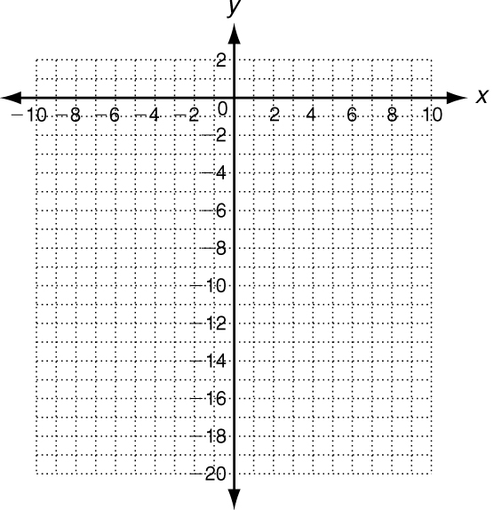
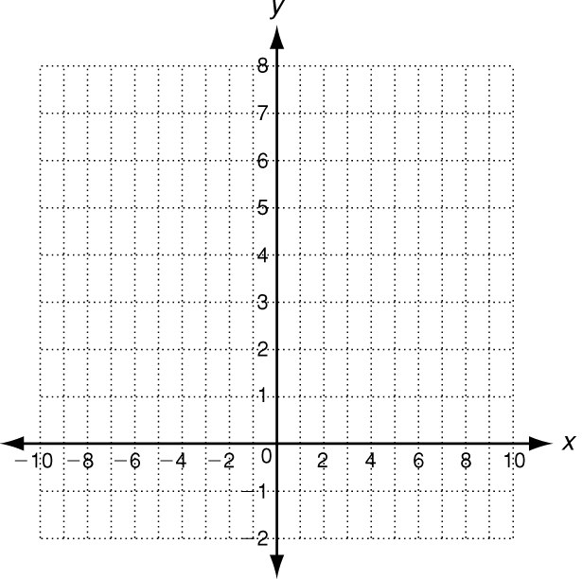

In the year 2000, the population of Virginia was about 7,400,000.
Between the years 2000 and 2004, the population in Virginia grew
at a rate of 5.4%. At this growth rate, the function f(x) = 7,400,000 (1.054)^{x} gives the population x years after 2000.
9. In what year will the population reach 15,000,000? ______________________________________
10. In what year will the population reach 20,000,000? ______________________________________

