8.2 Practice A
Characteristics of Quadratic Functions
Find the zeros of each quadratic function from its graph.
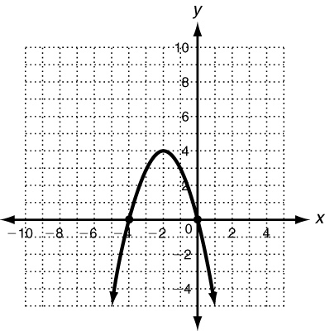
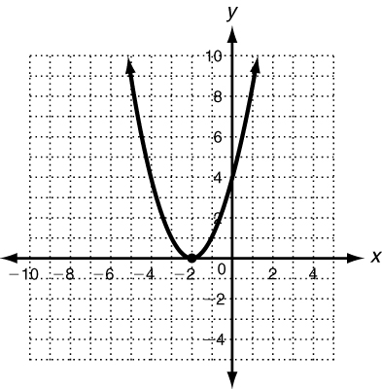
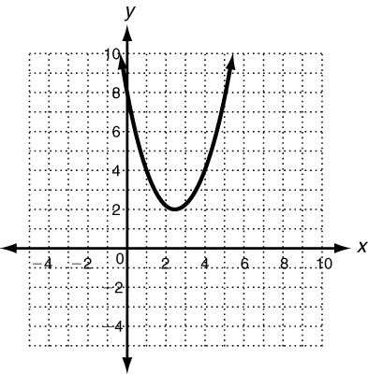
1. 2. 3.

Find the axis of symmetry of each parabola.
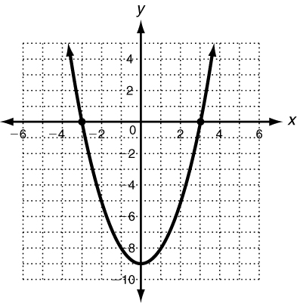
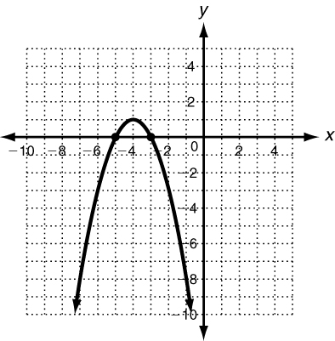
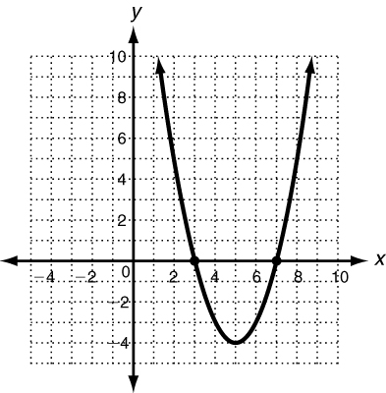
4. 5. 6.

Find the axis of symmetry and the vertex of each quadratic function by completing the following.
7. y  x ² + 8x + 12 8. y = x ² − 10x  40 9. y = 2x² − 8x − 3
Find a: Find a: Find a:
Find b: Find b: Find b:
Find 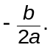 Find Find
Axis of symmetry: Axis of symmetry: Axis of symmetry:
Vertex: Vertex: Vertex:

8.2 Practice B
Characteristics of Quadratic Functions
Find the zeros of each quadratic function from its graph.
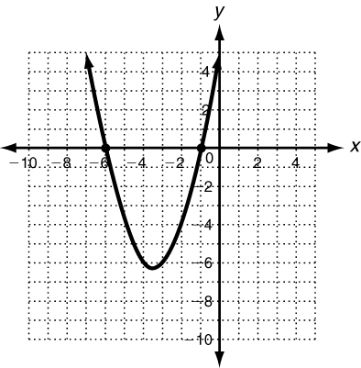
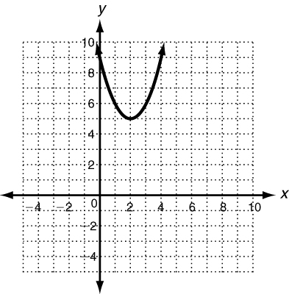
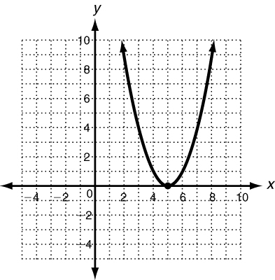
1. 2. 3.

Find the axis of symmetry of each parabola.
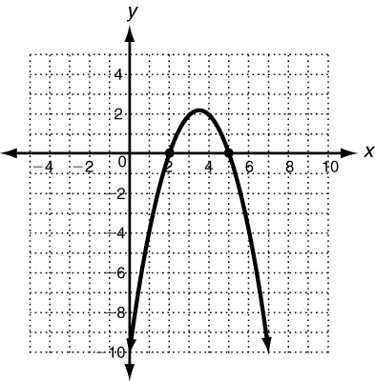
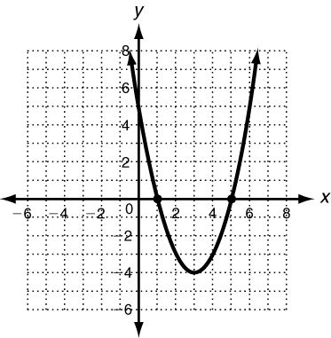
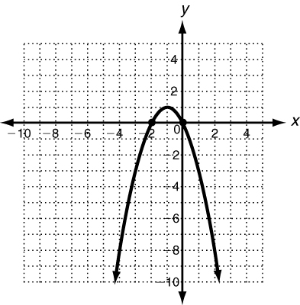
4. 5. 6.

For each quadratic function, find the axis of symmetry of its graph.
7. y  3x ² − 6x + 4 8. y = −x ² + 4x 9. y = 4x² + 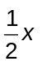 + 3

Find the vertex of each parabola.
10. y  3x ² − 6x − 2 11. y = 3x ² + 12x − 10 12. y = x ² + 2x − 35

