Name Date Class

Review for Mastery 5.6

Solving Systems of Linear Inequalities

For each system below, give two ordered pairs that are solutions and two that are not solutions.

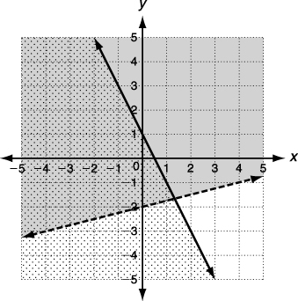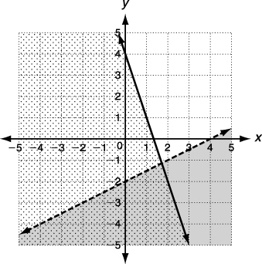

1. 2.

Graph each system of linear inequalities

3.  4. 

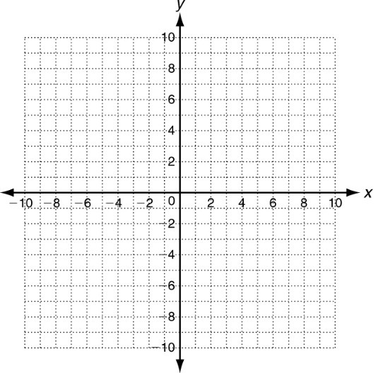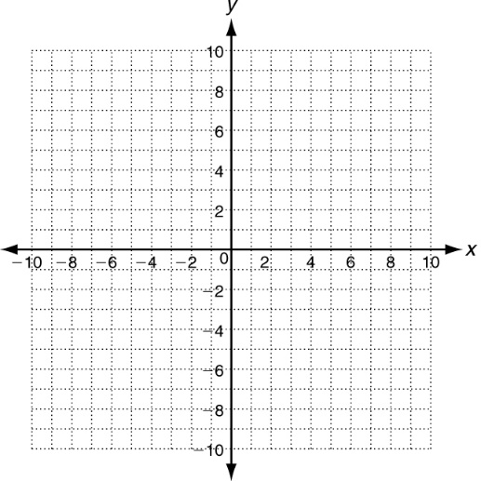

Graph the solutions of each linear inequality.

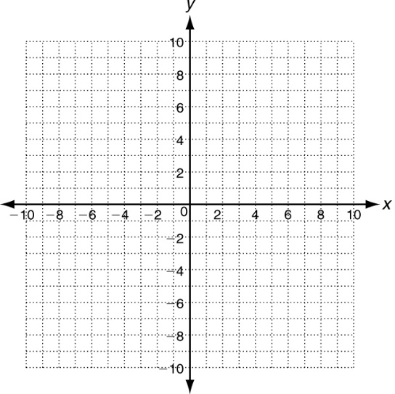 5.  6.  7. 

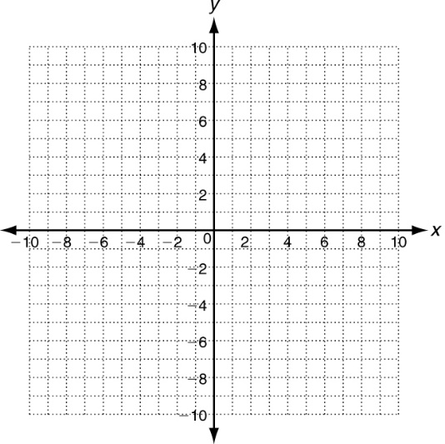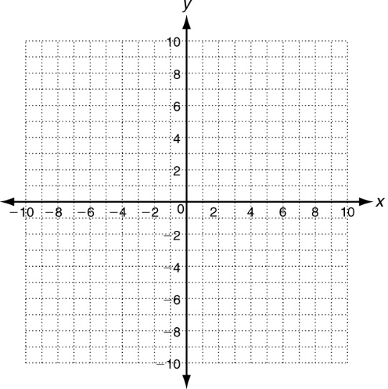

Practice 5.6 A

Solving Systems of Linear Inequalities

Tell whether the ordered pair is a solution of the given system.

1.  2.  3. 

Graph the system of linear inequalities. a. Give two ordered pairs  
that are solutions. b. Give two ordered pairs that are not solutions.

4.  5.  6. 

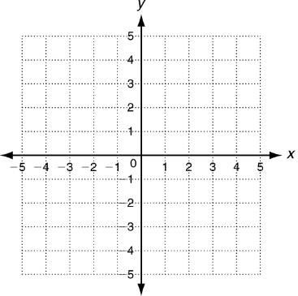

a. _________________ a. _________________ a. _________________

b. _________________ b. _________________ b. _________________

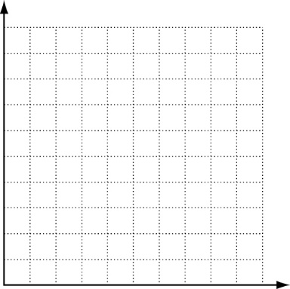 7. Lou is buying macaroni salad and potato salad for a picnic.   
Macaroni salad costs $4 per pound and potato salad costs  
$2 per pound. Lou would like to buy at least 6 pounds of   
salads and wants to spend no more than $20.

a. Write a system of linear inequalities.  
Let *x* = pounds of macaroni salad  
Let *y* = pounds of potato salad

b. Graph the solutions of the system.

c. Describe all the possible combinations of pounds of salads that Lou could buy.

d. List two possible combinations. ______________________________________________________

______________________________________________________