Name Date Class
4.4 Practice A
4-4 The Slope Formula

Find the slope of the line that contains each pair of points.
1. (3, 1) and (9, 2) 2. (−2, 3) and (2, −1) 3. (4, 6) and (0, −2)
m = 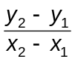 m = m =

Each graph or table shows a linear relationship. Find the slope.
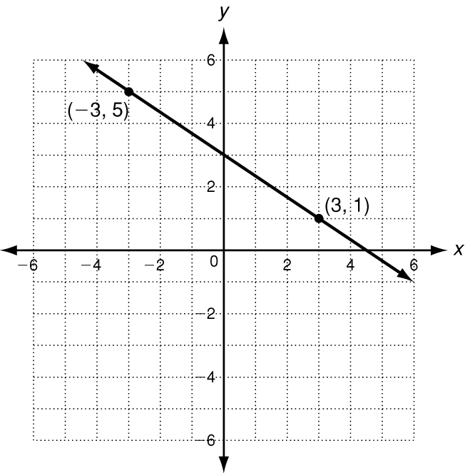
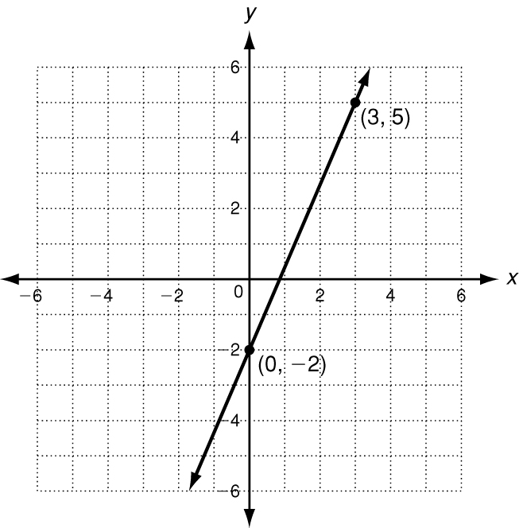
4. 5. 6.
x | y
0 | 82
3 | 76
6 | 70
9 | 64
12 | 58

Find the slope of each line. Then tell what the slope represents.
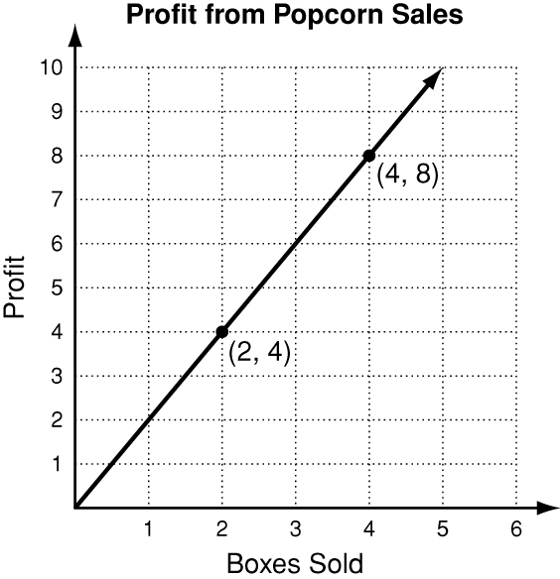
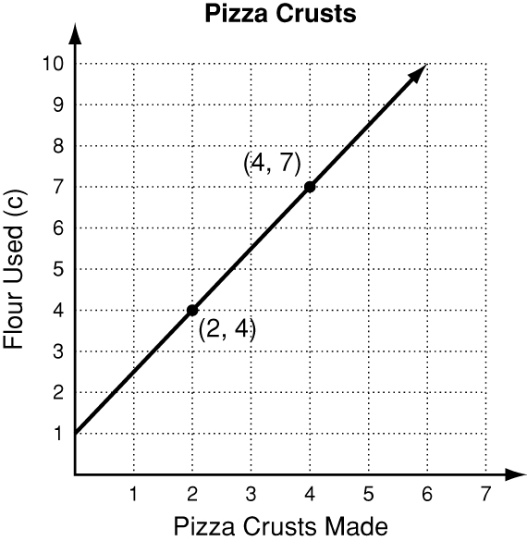
7. 8.

Complete the steps to find the slope of the line described by 2x + 5y = 10.
9. a. Find the x-intercept. b. Find the y-intercept. c. The line contains (____, 0)
d. The line contains ( 0, ___ )
e. The slope of the line is ___

4.4 Practice B
4-4 The Slope Formula

Find the slope of the line that contains each pair of points.
1. (2, 8) and (1, −3) 2. (−4, 0) and (−6, −2) 3. (0, −2) and (4, −7)
m = m = m =

Each graph or table shows a linear relationship. Find the slope.
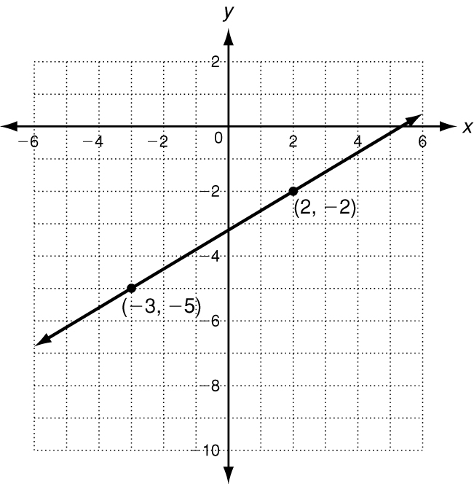
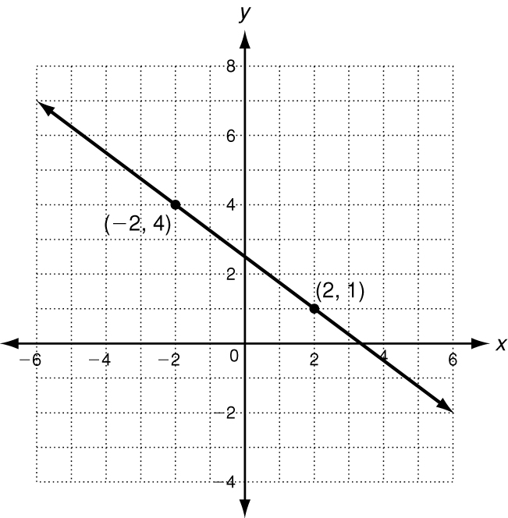
4. 5. 6.
x | y
1 | 3.75
2 | 5
3 | 6.25
4 | 7.50
5 | 8.75

Find the slope of each line. Then tell what the slope represents.
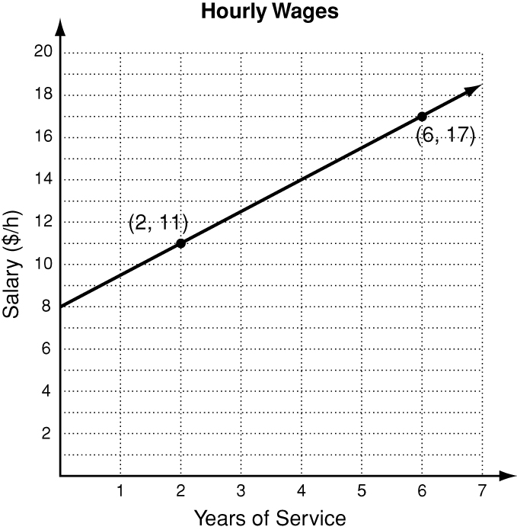
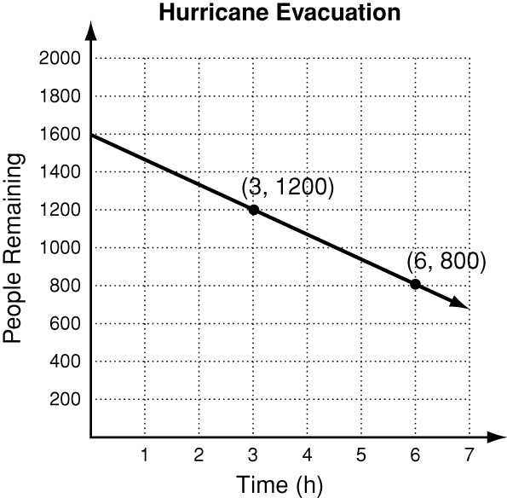
7. 8.

Find the slope of the line described by each equation.
9. 3x + 4y = 24 10. 8x + 48 = 3y

