4.2 Practice A
Using Intercepts
Find the x- and y-intercepts.
1. 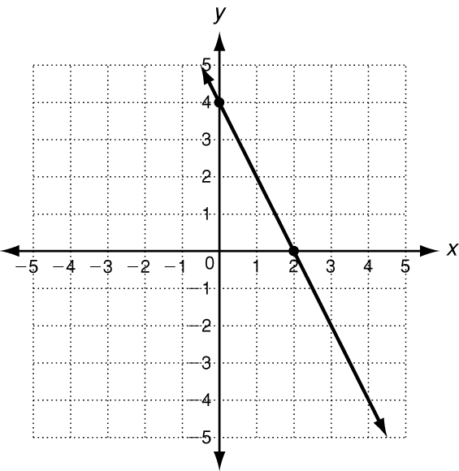 2. 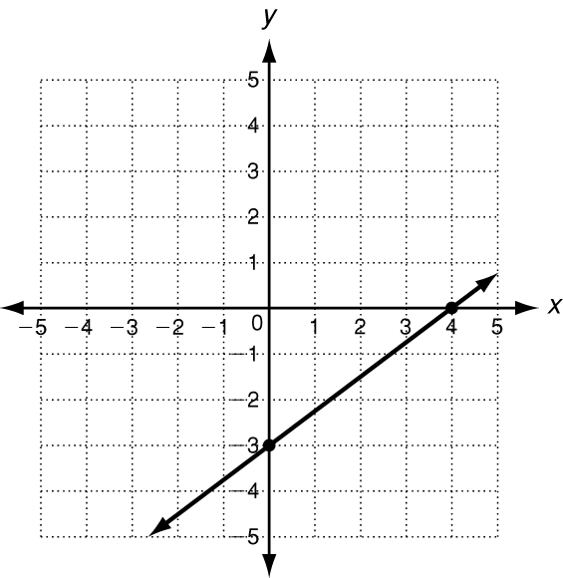 3. 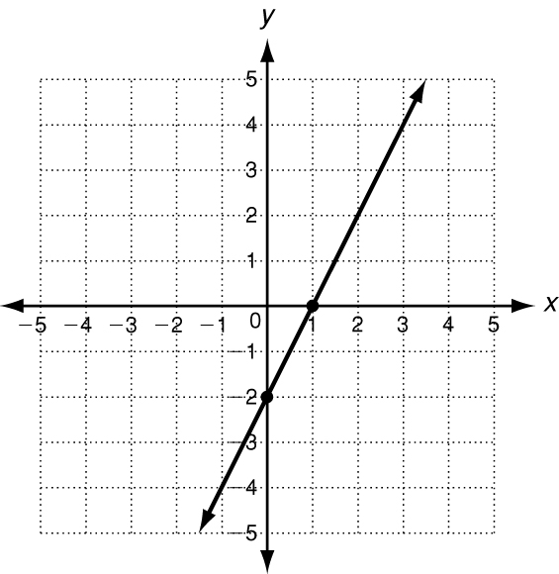

x-intercept: _____________ x-intercept: _____________ x-intercept: _____________
y-intercept: _____________ y-intercept: _____________ y-intercept: _____________
4. Find the intercepts of 2x + 3y  6 by following the steps below.
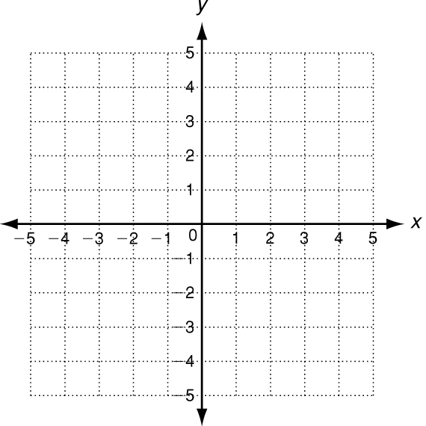
a. Substitute y  0 into the equation. Solve for x.

b. The x-intercept is: ________________________
c. Substitute x  0 into the equation. Solve for y.

d. The y-intercept is: ________________________
e. Use the intercepts to graph the line described by the equation.
5. Jennifer started with $50 in her savings account. Each week
she withdrew $10. The amount of money in her savings account
after x weeks is represented by the function f(x)  50 − 10x.
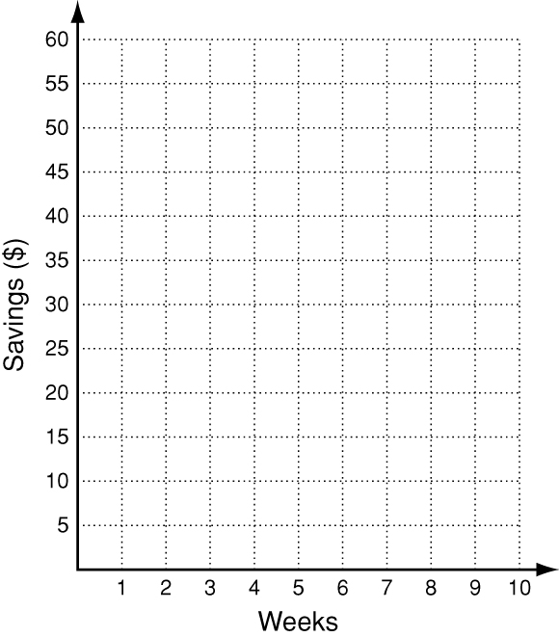
a. Find the intercepts and graph the function.

b. What does each intercept represent?

4.2 Practice B
Using Intercepts
Find the x- and y-intercepts.
1. 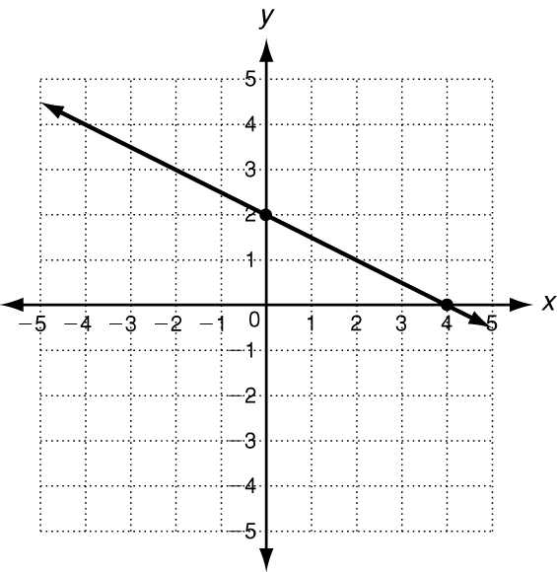 2. 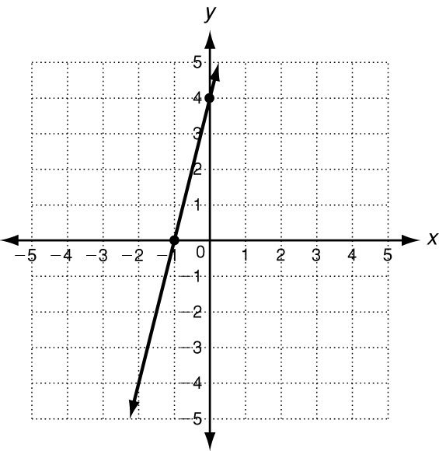 3. 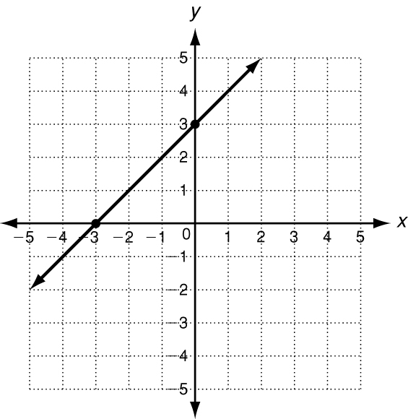

Use intercepts to graph the line described by each equation.
4. 3x + 2y = −6 5. x − 4y = 4
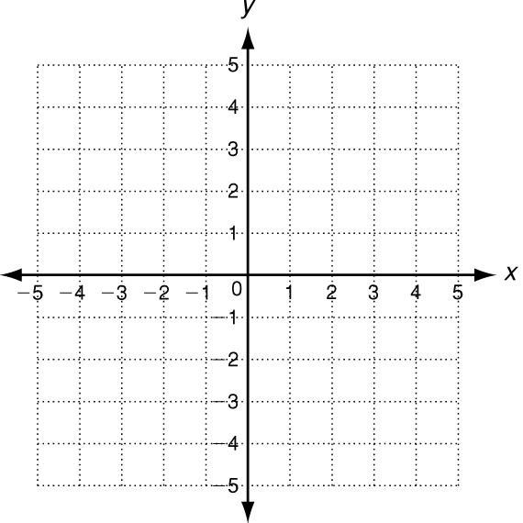
6. At a fair, hamburgers sell for $3.00 each and hot dogs sell for
$1.50 each. The equation 3x  1.5y = 30 describes the number
of hamburgers and hot dogs a family can buy with $30.
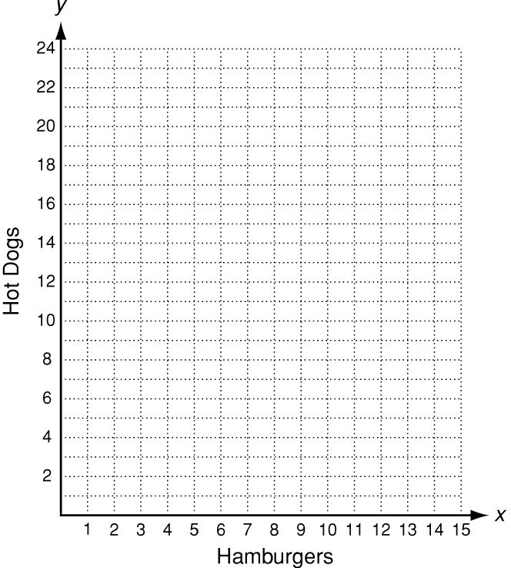
a. Find the intercepts and graph the function.

b. What does each intercept represent?

