4.1-4.4 Review Worksheet
Find the x and y intercepts of the equation.

- $x+y=5$
  - X-intercept:______________

  - Y-intercept:______________

- $x-3y=9$
  - X-intercept:______________

  - Y-intercept:______________

- $3x+y=15$
  - X-intercept:______________

  - Y-intercept:______________

- $y=\frac{1}{2}x+6$
  - X-intercept:______________

  - Y-intercept:______________

Use the graph to find the x-intercept and the y-intercept of the line.
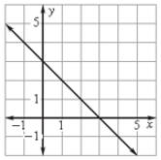
  - X-intercept:___________

  - Y-intercept:___________

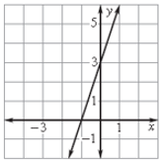
  - X-intercept:____________

  - Y-intercept:____________

State whether the slope of the line is positive, negative, zero, or undefined.

- _____________

- _____________
- _____________

- _____________

Find the slope of the line that passes through the given points.

- $\left(3, 7\right) and (-9, -5)$

- $\left(-2, 3\right) and \left(4, -1\right)$

- $\left(-5, 2\right) and (2, -4)$
- $\left(1, 5\right) and (2, 9)$

- $\left(2, 4\right) and (1, 1)$

- $\left(9, -6\right) and (3, -6$
Tell whether each set of ordered pairs satisfies a linear function. Explain.

- { (-3, 10), (-1, 9), (1, 7), (3, 4), (5, 0) }

- { (3, 4), (5, 7), (7, 10), (9, 13), (11, 16) }

Tell whether each function is linear or not. Explain how you know.
- y = 3 - 2x

- xy + 5 = 10
