1.1-1.4 Review & 1.5 Extension Worksheet
Name: _________________________________ Period:_____

Give two ways to write each algebraic expression in words.
- 2.
__________________________ __________________________
__________________________ __________________________
- 4.
__________________________ __________________________
__________________________ __________________________
Solve each equation.
- 6.

- 8. 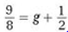

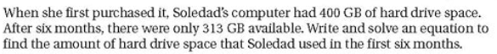

Solve each equation.
- 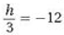 11. 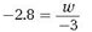

- 13.

Solve each equation.
- 16. 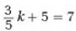

- 18.

- 20.

- 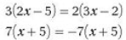 22.

- 24.

- 26.

- 28.

- A large forest fire in the western United States burns for 14 days, spreading to cover approximately 3850 acres. Firefighters do their best to contain the fire, but hot temperatures and high winds may prompt them to request additional support.
  - The fire spreads at an average rate of how many acres per day? ____________________
  - Officials estimate that the fire will spread to cover 9075 acres before it is contained. At this rate, how many more days will it take for the fire to cover an area of 9075 acres?
________________________________________________________________________
  - Additional help arrives, and the firefighters contain the fire in 7 more days. In total, how many acres does the fire cover before it is contained? ____________________________
  - If the fire had spread to cover an area of 7000 acres, it would have reached Bowman Valley. Explain how the graph shows that firefighters stopped the spread of the fire before it reached Bowman Valley. ____________________________________________
________________________________________________________________________
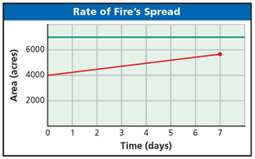
  - The total cost of fighting the fire for 21 days was approximately $1,440,000. What was the approximate cost per acre of fight the fire? _________________________________

