Name Date Class

Chapter 5: Systems of Equations

Select the best answer.

1. Which ordered pair is a solution of ?

A (−1, −1) B (3, 1)

2. The graph of a system of linear equations is shown below. What is the solution of the system?

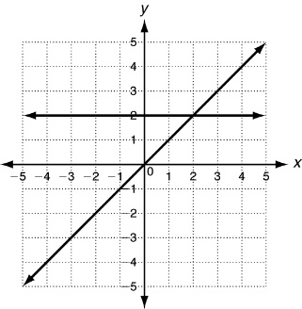

A (0, 0)

B (2, 2)

C (0, 2)

D (1, 1)

3. Solve by substitution: 

A (2.5, 3.5) B (0, 1) C (6, 7) D (3, 4)

4. Solve by elimination: 

A (4, −2) B (8, −6)

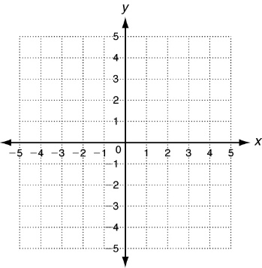5. . Leslie joins a fitness club that has a membership fee of $20 plus $15 per month.

Rashad’s club has a fee of $40 and charges $10 per month. In how many

months will the two clubs cost the same?

A 4 months B 12 months

6. Solve by any method: 

A (2, 1) B (1, 2)

7. Which term describes a system with exactly one solution?

A consistent & independent B consistent & dependent C inconsistent D dependent

8. Which equation would make this system have an infinite number of solutions? 

A 2y = 2x + 2 B y − 2 = x C y = 2x D y = 3x − 1

9. Solve 

A no solution B infinitely many solutions

10. Which ordered pair is a solution of y < x + 1?

A (0, 2) B (1, 3) C (2, 3) D (3, 3)

11. The solution of which linear inequality is graphed below?

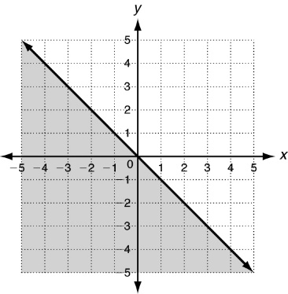

A y < −x

B y > −x

C y ≤ −x

D y ≥ −x

12. For which system of linear inequalities is the ordered pair (1, −1) a solution?

A  B 

13. The graph of a system of linear inequalities is shown below. Which ordered pair is a solution of the system?

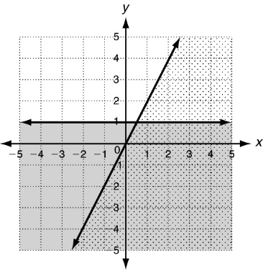

A (−2, 2)

B (4, 3)

C (2, −2)

D (−4, 0

Chapter 6: Exponents & Polynomial.

10. Simplify 

A  B

11. Simplify .

A 10 B 16 C 32 D 64

12. Simplify 

A 3 B 81

13. Simplify .

A  B

14. Simplify 

A  B 8

15. Simplify 

A 2 B 4

16. Simplify .

A 9 B 18

1. Which of the following is equivalent to 64?

A (6)4 B 

2. Evaluate x3 for x = 2.

A 8 B 6 C  D 

3. Simplify 2a0.

A 0 B 1 C 2 D 2a

4. Simplify .

A 1 B 5

5. Simplify .

A 0 B 1 C 64 D 640

6. Simplify .

A 256 B 

7. Simplify .

A 2 B 4 C 8 D 12

8. Simplify .

A5 B 5 C 25 D 12

9. Simplify .

A 2 B  C 8 D 16

17. Simplify . All variables represent nonnegative numbers.

A B  C  D 2*x*3*y*

18. Which polynomial is written in standard form?

A 5x3 + 2x + 9x2 B 5x3 + 9x2 + 2x C 2x + 9x2  5x3 D 9x2 + 2x  5x3

19. Classify the polynomial 5x2 + 9x + 1 according to its degree.

A cubic B linear C quadratic D quintic

20. Evaluate 4w2 + 3 for w = 5.

A 103 B 112 C 403 D 529

21. Add (2x3  5) + (x3 + 3).

A 3x3  2 B 3x6  2

22. Subtract (6a2 + 3a)  (4a2 + 2a).

A 2a2 + a B 2a2 + 5a C 3 D 3a3

23. Multiply .

A  B  C  D 

24. A rectangle has width w and its length is 2 units longer than the width, or w + 2. Write a polynomial for the area of the rectangle.

A w2 + 2 B w2 + 2w C 2w + 2 D 4w + 4

25. Multiply (x + 2)(x + 3).

A x2 + 6 B x2 + 5x + 6

26. Multiply (b + 3)(b2 + 2b + 1).

A b3 + 2b3 + 3 B b3 + 5b2 + 7b + 3 C 3b3 + 6b2 + 3b D 4b5 + 8b3 + 3b

27. Multiply (x + 7)(x  7).

A x2  49 B x2 + 14x  49

28. Which product results in x2 + 10x + 25?

A (x  5)2  B (x + 5)2 C (x + 5)(x  5) D (x + 5)(2x + 5)

Chapter 7: Factoring Polynomials

1. Which is the prime factorization of 24?

A 2 • 2 • 2 • 3 B 4 • 6

2. Find the GCF of 12 and 30.

A 2 B 3 C 6 D 36

3. Find the GCF of 5x 3 and 15x.

A 5x B 5x 3 C 15x D 15x 3

4. Shadé is organizing the members of a chorus into rows for a performance. The chorus consists of 70 women and 42 men. Each row will have the same number of people, but women and men will not appear in the same row. If she puts the greatest possible number of people in each row, how many rows will there be?

A 8 B 14

5. Factor 16y 2 + 12y completely.

A y(16y + 12) B 2y(8y + 6) C 4(4y 2 + 3y) D 4y(4y + 3)

6. Factor n(n + 2) + 7(n + 2).

A (n + 2) (n + 7) B 2(n + 2) (n + 7)

7. Factor a 2 + 3a + 8a + 24 by grouping.

A (a + 3) (a + 8) B (a2 + 3a) (8a + 24) C 8a(a + 3) D cannot be factored

8. Factor x 2 + 12x + 35.

A (x + 1) (x + 35) B (x + 5) (x + 7)

9. Factor x 2 − 23x + 22.

A (x − 2) (x − 11) B (x − 1) (x − 22) C (x + 1) (x − 23) D cannot be factored

10. Factor x 2 + 13x − 13.

A (x − 1) (x + 13) B (x − 1) (x + 14) C (x + 1) (x + 12) D cannot be factored

13. Factor 2x 2 + 23x + 11.

A (x + 1) (2x + 11) B (2x + 1) (x + 11)

14. Factor 5a 2 − 3a − 2.

A (a − 2) (5a + 1) B (a − 1) (5a + 2) C (a + 1) (5a − 2) D cannot be factored

16. Determine whether n 2 + 20n + 100 is a perfect square trinomial.

A yes B no

17. Determine whether x 2 − 6x − 9 is a perfect square trinomial. If so, choose the correct factorization.

A yes; (x − 3) 2  B yes; (x + 3) 2  C yes; (x + 3) (x − 3) D no

18. Determine whether p 2 − 40 is a difference of two squares.

A yes B no

19. Determine whether x 2 − 16 is a difference of two squares. If so, choose the correct factorization.

A yes; (x − 4) 2  B yes; (x + 4) (x − 4) C yes; (x + 4) 2  D no

20. The area of a square is represented by z 2 + 10z + 25. Which expression represents the perimeter of the square?

A z + 5 B z + 9 C 2z + 10 D 4z + 20

21. Is 5x(x 2 + 36) completely factored?

A yes; the polynomial is completely factored. B no; x 2 + 36 can be factored into two binomials.

22. Completely factor x 4 + 2x 3 − 15x 2.

A (x 2 + 5x) (x 2 − 3x) B x 2(x + 5) (x − 3)

Chapter 8: Quadratic Functions & Equations

Select the best answer.

1. What function is quadratic?

A 3x − 2y = 5 B 5x 2 + x = y − 4

2. The vertex of this parabola shows that the _____ value of the function is _____.

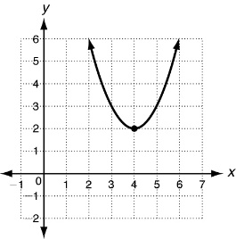

A maximum, 2

B maximum, 4

C minimum, 2

D minimum, 4

3. Which table of values would you use to graph y = 3x 2?



4. Find the zeros of y = x 2 − 8x + 12 from its graph below.

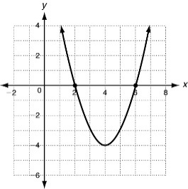

A −2 and −6

B 0 and 4

C 2 and 6

D 4 and −4

5. Find the axis of symmetry of this parabola.

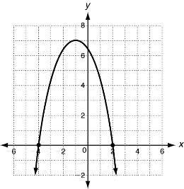

A x = −2

B x = −1

C x = 1

D x = 3

6. If you graph y = x 2 − 6x + 9, the y-intercept would be ___________.

A −3 B 9

8. Compare the graph of g(x) = x 2 + 6 with the graph of f (x) = x 2.

A g(x) is wider. B g(x) is narrower. C g(x) is translated 6 units down. D g(x) is translated 6 units up.

9. Use this graph of the quadratic function y = x 2 + 4x + 4 to solve the equation x 2 + 4x + 4 = 0.

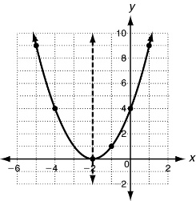

A x = −2

B x = −3 or x = −1

C x = −4 or x = 0

D x = −5 or x = 1

10. Solve x 2 − 7x − 8 = 0 by factoring.

A x = −1 or x = 8 B x = 1 or x = −8

12. Solve x 2 = 9 using square roots.

A x = 3 B x = 81

13. Solve 9x 2 − 4 = 0 using square roots.

F x =  G x= H x =  J x=

14. Solve x 2 + 10x = 39 using the Quadratic Formula.

A x = −13, 3 B x = −10 $±$ C x = −5  D x = 5 

15. Solve 2x 2 + 9x + 4 = 0 using the Quadratic Formula.

A x = −4 or x = − B x = 

16. Find the number of real solutions of the equation x 2 + 11x − 10 = 0 using the discriminant.

A 0 B 1 C 2 D 3

Chapter 9: Exponential Functions

1. Find the next three terms in this sequence: 4, 12, 36, 108, …

A 180, 252, 324 B 324, 972, 2916

2. The first term of a geometric sequence is 5 and the common ratio is 2. What is the 4th term of the sequence?

A 40 B 80 C 250 D 1250

3. Which graph shows y = 2(4)x?

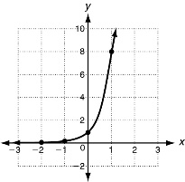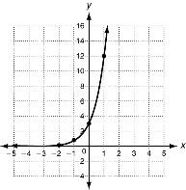A B

4. The function f(x) = 10(2)x models an insect population after x weeks. To the nearest whole number, what will the population be after 4 weeks?

A 80 B 160 C 20,000 D 160,000

5. Which are the next three terms in the geometric sequence 1, 2, 4, 8, …?

A 12, 24, 48 B 16, 32, 64 C 4, 2, 1 D 10, 12, 14

6. Which is the 10th term of the geometric sequence , 1, …?

A 729 B 243 C 81 D 27

7. Which is the 6th term of the geometric sequence 1024, 512, 256,…?

A 64 B 32 C 16 D 8

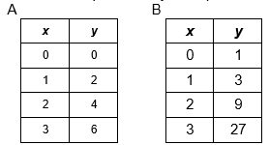

8. Which ordered pairs satisfy an exponential function?

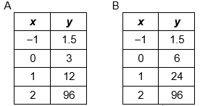

9. Which set of ordered pairs satisfies an exponential function?

10. The original value of a sculpture is $950, and the value increases by 15% each year. Find the value of the sculpture in 8 years.

A $1092.52 B $2090.00 C $2906.07 D $3013.56

11. A new play premiers on Saturday, October 1, and 420 people attend Attendance then decreases by 30% each day. Find the attendance on Tuesday, October 4.

A 144 B 383

12. Determine which kind of model best describes this data set. {(−2, 1), (−1, 3), (0, 5), (1, 7), (2, 9)}

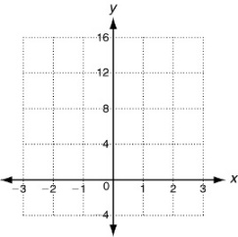

A linear

B exponential

C quadratic

D none

14. Which of the following models best describes the data set? {(1, 1), (0, 0), (1, 1), (2, 4)}

A linear B quadratic C exponential D none

15. Ben has $100 in his savings account. He wants to save more money. He is looking at two investment plans. Under plan A, he will increase his account balance by $20 a year. Under plan B, he will increase his account balance by 15% each year. How much more will he save with Plan B after 10 years?

A $105 B $46 C $13 D $1

16. Which is the average rate of change over the interval [0, 2]?

Equation A

|  |  |  |  |  |
| --- | --- | --- | --- | --- |
| ***X*** | 0 | 1 | 2 | 3 |
| ***Y*** | 0 | 1 | 4 | 9 |

Equation B



A A: 4, B: 1 B A: 2, B: 1 C A: 2, B: 4 D A: 4, B: 3.