Name Date Class
Chapter 8: Quadratic Functions Review

- What is the quadratic formula: $x= _______________________$

Matching.

2. If $b^{2}-4ac>0$ then there are ___________ solutions.

3. If $b^{2}-4ac=0$ then there are ___________ solutions.

4. If $b^{2}-4ac<0$ then there are ___________ solutions.

Simplify the radicals.
$\sqrt{100}$ $\sqrt{\frac{8}{5}}$ $\sqrt{\frac{5}{6}}$ $\sqrt{12}$

Identify the quadratic functions.
$y^{2}+x=2$ $2x+y=4x-1$ ${3x}^{2}+4=-2x$

x | -2 | -1 | 0 | 1 | 2
y | -2 | 0 | 4 | 9 | 15
x | -2 | -1 | 0 | 1 | 2
y | 39 | 18 | 3 | -6 | -9

Identify the axis of symmetry, vertex, zeros, domain and range of the following graph.
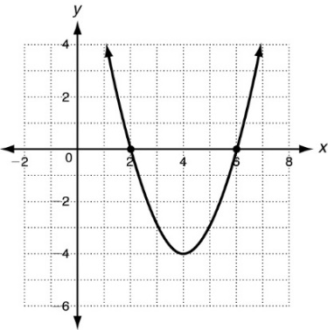
Axis of symmetry: ______________

Vertex: ________

Zeros: _________

Domain: ___________

Range: ___________
Identify the axis of symmetry, vertex, zeros, y-intercept, domain and range of the following graph.
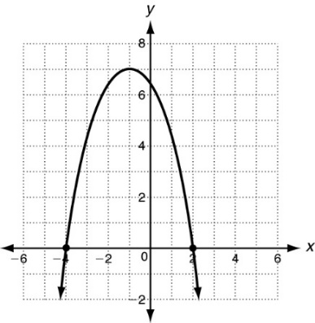
Axis of symmetry: ______________

Vertex: ________

Zeros: _________

y-intercept: _________

Domain: ___________

Range: ___________

Compare the graph of the following graph with the graph of f (x) = x ².
$g\left(x\right)=6x^{2}$
$$p\left(x\right)=x^{2}-4$$
$$k\left(x\right)=\frac{1}{2}x^{2}+3$$

Solve the following equations.
$-3x\left(2x-1\right)=0$ $\left(x-2\right)\left(x+4\right)=0$ $x^{2}-5x+6=0$

${25x}^{2}-16=0$ $x^{2}-2x-15=0$ ${(x-1)}^{2}=36$

Solve using the quadratic formula. You must show your work to earn full credit.
$${4x}^{2}-4x-3=0$$

Find the number of real solutions of the following equations using the discriminant.
${ 100x}^{2}+49=0$ $x^{2}-2x-4=0$ ${2x}^{2}+3=2x$

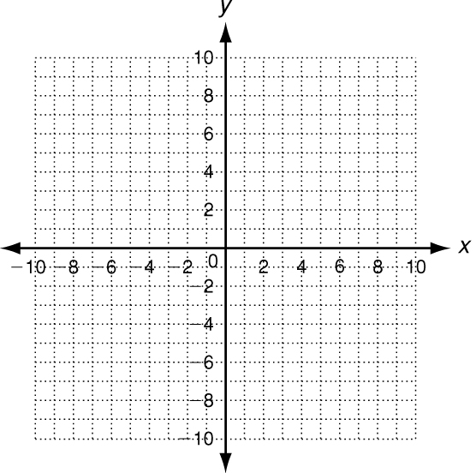
Graph the following function. Then identify the following: axis of symmetry, vertex, minimum or maximum, minimum or maximum value, zeros, y-intercept, domain, and range of the following function:
$$y=x^{2}+14x+40$$
Axis of Symmetry: $x=_______$
Vertex: _________
Circle One: Minimum or Maximum
Minimum or Maximum Value: _____
Zeros: $x=______$, _____
y-intercept: ______
Domain:______
Range: __________

