10.4 Tangent Ratio
Goal: Use the tangent ratio to find missing sides of right triangles.
Trigonometric ratio: a ratio of the lengths of two sides of a _______________ triangle
Tangent Ratio
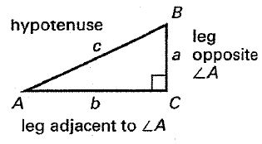

tan = _________________

Find tan D and tan E as fractions.

a) tan D = ______ b) tan D = ______
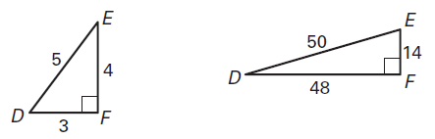
tan E = ______ tan E = ______

c) tan D = ______ d) tan D = ______
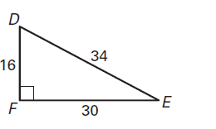
tan E = ______ tan E = ______
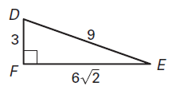

Use a calculator to approximate the value to two decimal places.
a) $\tan{34°}$ b) $\tan{71°}$ c) $\tan{45°}$ d) $\tan{20°}$

Use the tangent ratio to find the value of x. Round to the nearest tenth.
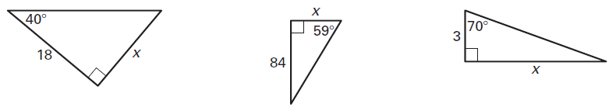
a) x = _______ b) x = _______ c) x = _______

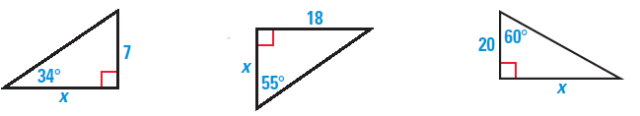
d) x = _______ e) x = _______ f) x = _______

10.5 Sine and Cosine Ratios
Goal: Use the sine and cosine ratios to find missing sides of right triangles.
Sine Ratio | Cosine Ratio
sin = _________________ | cos = _________________

To remember the trigonometric ratios, just remember ________________________

Find the indicated ratios. Write your answer as fractions.

a) sin A = _______ sin B = _______ b) sin A = _______ sin B = _______

cos A = _______ cos B = _______ cos A = _______ cos B = _______
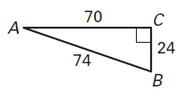
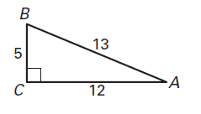

c) sin D = _______ sin E = _______ d) sin A = _______ sin B = _______

cos D = _______ cos E = _______ cos A = _______ cos B = _______
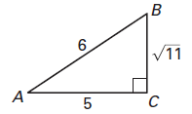

Use a calculator to approximate the value to two decimal places.
a) $\sin{33°}$ b) $\cos{33°}$ c) $\sin{8°}$ d) $\cos{67°}$

e) $\sin{85°}$ f) $\cos{13°}$ g) $\sin{0°}$ h) $\cos{0°}$

Find the value of x. Round to the nearest tenth.
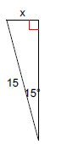
a) x = _______ b) x = _______ c) x = _______
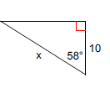
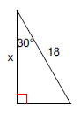

d) x = _______ e) x = _______ f) x = _______
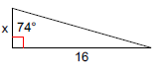
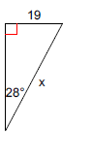
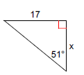

Find the lengths of the legs of the triangle. Round your answers to the nearest tenth.
a) x = _______ y = _______ b) x = _______ y = _______ c) x = _______ y = _______
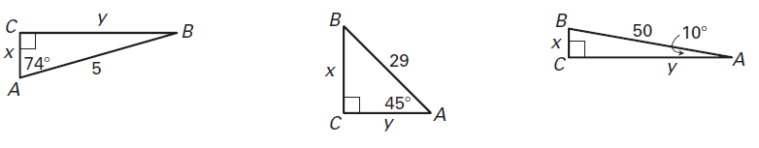

10.6 Solving Right Triangles – Day 1
Goal: Use inverse trigonometric functions to find missing angles
Inverse tangent: a function available on a calculator as $\tan^{-1}{x}$, which can be used to find the measure of an ____________ when you know the ______________ of the angle
Inverse sine: a function available on a calculator as $\sin^{-1}{x}$, which can be used to find the measure of an ____________ when you know the ______________ of the angle
Inverse cosine: a function available on a calculator as $\cos^{-1}{x}$, which can be used to find the measure of an ____________ when you know the ______________ of the angle
To find missing sides we use: _________________________________________
To find missing angles we use: ________________________________________

$∠A$ is an acute angle. Use a calculator to approximate the measure of $∠A$ to the nearest degree.

a) $\tan{A=3.5}$ b) $\tan{A=2}$ c) $\tan{A= 0.4402}$

$m∠A= _______$ $m∠A= _______$ $m∠A= _______$

d) $\sin{A=0.5}$ e) $\cos{A=0.92}$ f) $\sin{A}=0.1149$

$m∠A= _______$ $m∠A= _______$ $m∠A= _______$

g) $\cos{A=\frac{2.4}{4}}$ h) $\cos{A=\frac{15}{17}}$ i) $\tan{A}=\frac{11}{7}$

$m∠A= _______$ $m∠A= _______$ $m∠A= _______$
Use the inverse trigonometry functions to find the measure of each missing angle. Round to the nearest degree.

a) $m∠A=________$ $m∠B=________$ b) $m∠A=________$ $m∠B=________$
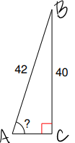
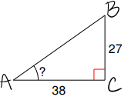

c) $m∠A=________$ $m∠B=________$ d) $m∠A=________$ $m∠B=________$
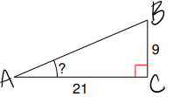
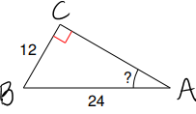

e) $m∠A=________$ $m∠B=________$ f) $m∠A=________$ $m∠B=________$
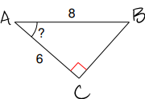
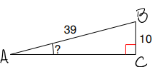

10.6 Solving Right Triangles – Day 2
Goal: Use inverse trigonometric functions to solve right triangles.
Solve a right triangle: to find the measures of both acute ___________ and all three ____________

Solve the right triangle. Find all missing sides and angles. Round sides to the nearest tenth and angles to the nearest degree.

a) x = ______ $m∠A= ________$ $m∠B= ________$ b) a = ______ $m∠A= ________$ $m∠B= ________$
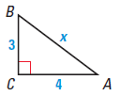
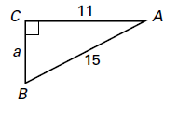

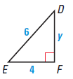
c) y = ______ $m∠D= ________$ $m∠E= ________$ d) z = ______ $m∠G= ________$ $m∠H= ________$
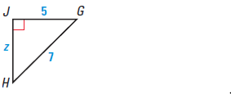

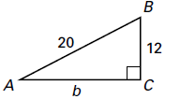
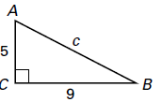
e) c = ______ $m∠A= ________$ $m∠B= ________$ f) b = ______ $m∠A= ________$ $m∠B= ________$

