8.3 Practice A

Graphing Quadratic Functions

Identify the following components of each quadratic function.   
Then graph the function.

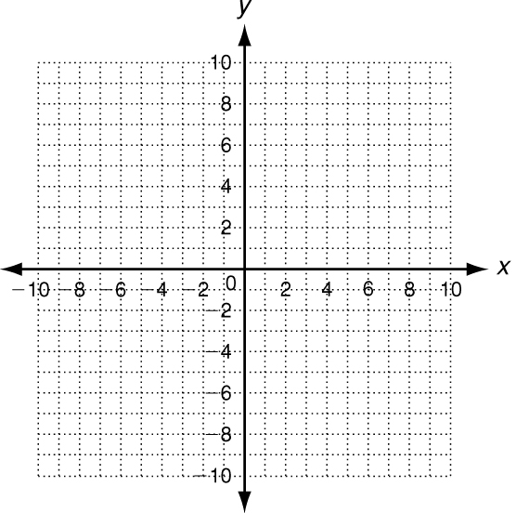 1. y = x2 + 2x − 3

axis of symmetry x = : _________________

vertex : ______________________________

y-intercept (c): _________________________________

two other points: _______________________________

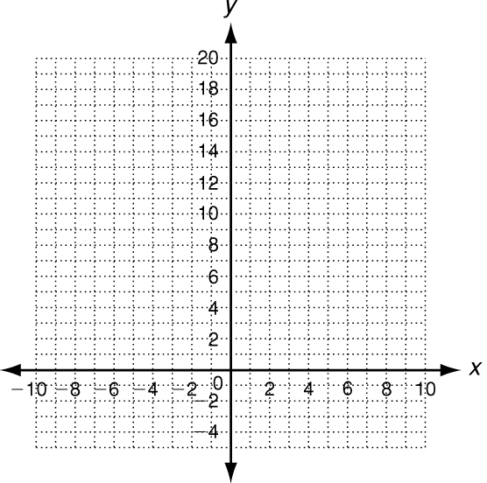

2. y = −2x2 − 8x + 10

axis of symmetry x = : _________________

vertex : ______________________________

y-intercept (c): _________________________________

two other points: _______________________________

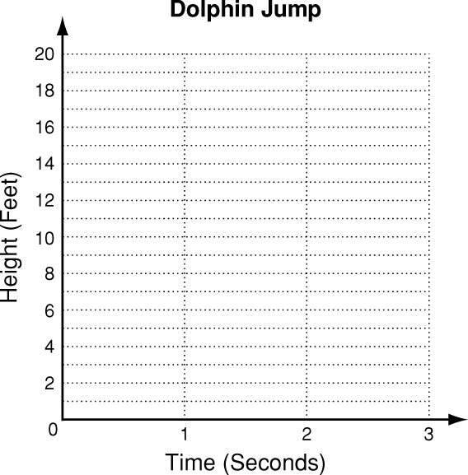

3. The height in feet of a dolphin as it jumps out  
of the water at an aquarium show can be  
modeled by the function f(x) = −16x2 + 32x,  
where x is the time in seconds after it exits the  
water. Graph this function. Find the dolphin’s  
maximum height and the time it takes to reach  
this height. Then find how long the dolphin is  
in the air.

maximum height: ______________________________

time to reach maximum height: _________________

time in the air: _________________________________

8.3 Practice C

Graphing Quadratic Functions

Graph each quadratic function.

1. x2 + y = −6x + 16 2. y − 2x2 − x + 10 = 0

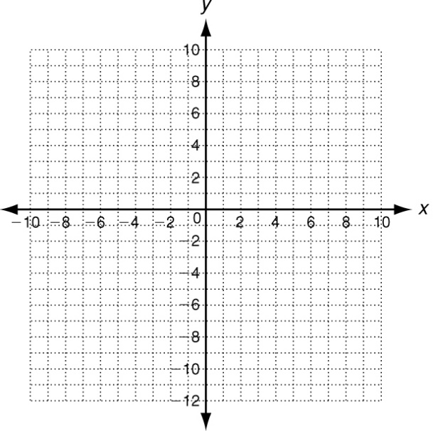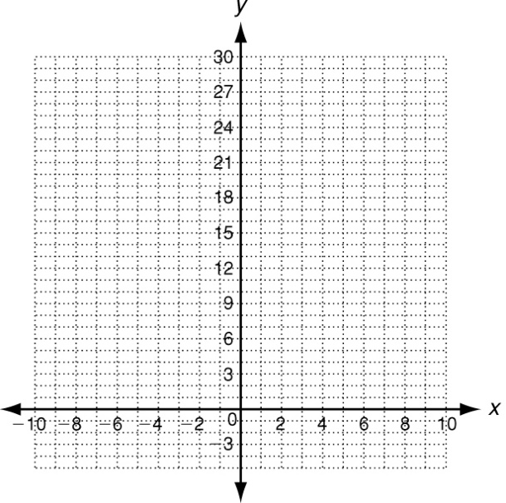

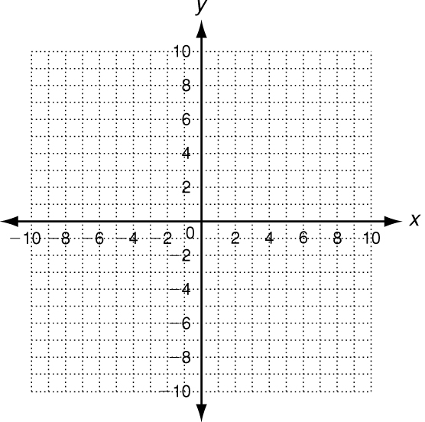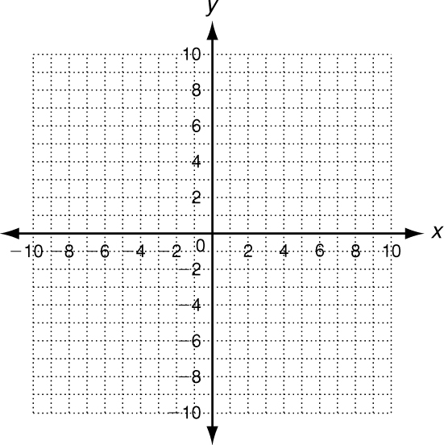 3. y − 4x =  4. y + 8 + 3x2 = 12x

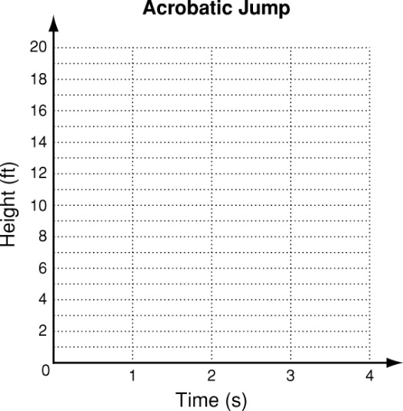

5. The height in feet of an acrobat who jumps from  
a trampoline 10 feet in the air to a large mat on  
the ground can be modeled by the function  
f(x) = −8x2 + 16x + 10, where x is the time in   
seconds after the acrobat jumps. Graph this function.  
Find the maximum height of the acrobat and the   
time it takes to reach this height. Then find how   
long the acrobat is in the air.

maximum height: _______________________________

time to reach maximum height: __________________

time in the air: __________________________________