6.6 Practice A

Special Products of Binomials

Fill in the blanks below. Then simplify.

1. (x + 5)2 2. (*m* + 3)2 3. (2 + *a*)2

  

.

Multiply.

4. (x + 4)2 5. (a + 7)2 6. (8 + *b*)2

Fill in the blanks below. Then simplify.

7. (x − 10)2 8. (y − 6)2 9. (9 − x)2

  

Multiply.

10. (y − 7)2 11. (b − 11)2 12. (3 − *x*)2

Fill in the blanks below. Then simplify.

13. (x + 7) (x − 7) 14. (4 + y) (4 − *y*) 15. (x + 2) (x − 2)

  

Multiply.

16. (x + 8) (x − 8) 17. (3 + y) (3 − *y*) 18. (x + 1) (x − 1)

6.6 Practice B

Special Products of Binomials

Multiply.

1. (x + 2)2 2. (*m* + 4)2 3. (3 + *a*)2

4. (2x + 5)2 5. (3a + 2)2 6. (6 + 5*b*)2

7. (b − 3)2 8. (8 − y)2 9. (a − 10)2

10. (3x − 7)2 11. (4*m* − 9)2 12. (6 − 3*n*)2

13. (x + 3) (x − 3) 14. (8 + y) (8 − *y*) 15. (x + 6) (x − 6)

16. (5x + 2) (5x − 2) 17. (10*x* + 7y) (10*x* − 7*y*) 18. (x2 + 3*y*) (x2 − 3*y*)

19. Write a simplified expression that represents the...

a. area of the large rectangle.

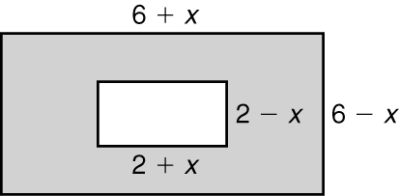

b. area of the small rectangle.

c. area of the shaded area.

20. The small rectangle is made larger by adding 2 units  
to the length and 2 units to the width.

a. What is the new area of the smaller rectangle?

b. What is the area of the new shaded area?