***6.5 Multiplying Polynomials***

**Multiply.**

1. (6*m*4) (8*m*2) 2. (5*x*3) (4*xy*2) 3. 4(*x*2 + 5*x* + 6)

4. 7*xy*(3*x*2 + 4*y* + 2) 5. (*x* + 3) (*x* + 4) 6. (*x* − 6) (*x* − 6)

7. (2*x* + 5) (*x* + 6) 8. (*a*2 + *b*2) (*a* + *b*) 9. (*x* + 4) (*x*2 + 3*x* + 5)

10. (3*m* + 4) (*m*2 − 3*m* + 5) 11. (2*x* − 5) (4*x*2 − 3*x* + 1)

12. **The length of a rectangle is 3 inches greater than the width.**

a. Write a polynomial that represents the area  
of the rectangle. ______________________________________

b. Find the area of the rectangle when the  
width is 4 inches. ______________________________________

13. **The length of a rectangle is 8 centimeters less than 3 times the width.**

a. Write a polynomial that represents the area  
of the rectangle. ______________________________________

b. Find the area of the rectangle when the  
width is 10 centimeters. ______________________________________

14. Write and simplify a polynomial to represent the volume of the rectangular prism.

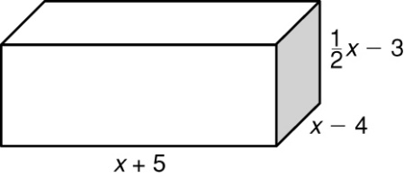

____________________________

**Simplify.**

15.  16.  17. 

18.  19.  20. 

**Simplify each expression.**

21.  22.  23. 

24.  25.  26. 

**Classify each polynomial according to its degree and number of terms.**

27. 7*x*2 − 5*x* 28. *b*3 + 2*b*2 − 4*b* + 1

**Write each polynomial in standard form. Then give the leading coefficient.**

29. *x*3− 5*x*4 − 6*x*5 ___________________ ___________________

30. 2*x* + 5*x*2− *x*3 ___________________ ___________________

**Simplify.**

31. (2*y*5 − 6*y*3 + 1) + (*y*5 + 8*y*4 − 2*y*3 − 1)

32. (4*c*5 + 8*c*2 − 2*c* − 2) − (*c*3 − 2*c* + 5)