Name Date Class
Review for Mastery 5.5
Solving Linear Inequalities
The boundary lines for each inequality are graphed below. Shade the correct side
1. y > 5x + 7 2. y < −2x − 9 3. x > 3
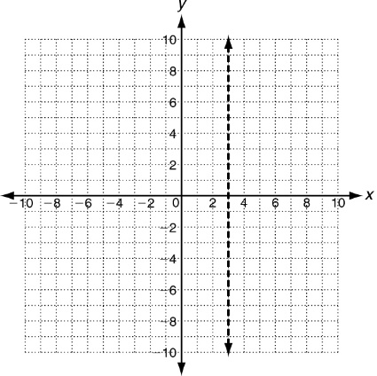
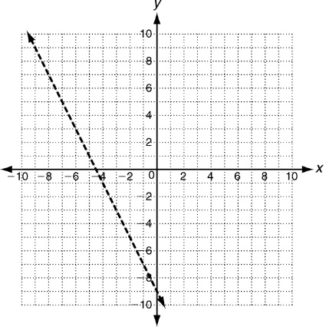
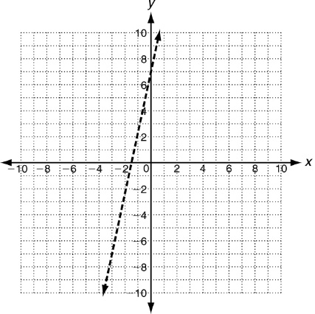

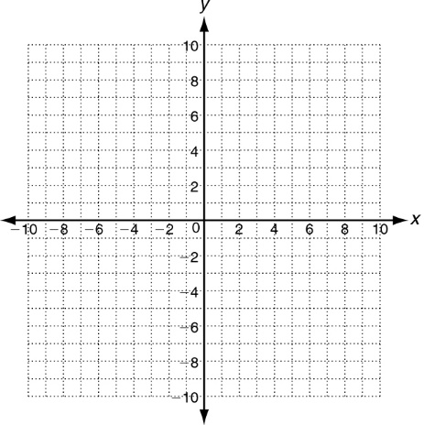
Graph the solutions of each linear inequality.
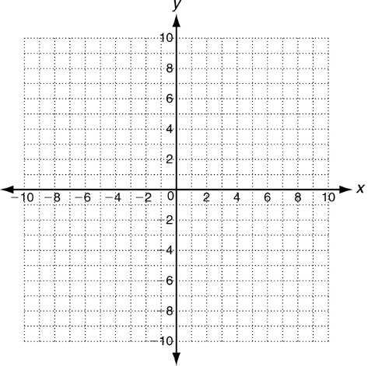
4. y − x < 3 5. x + y + 2 ≥ 0

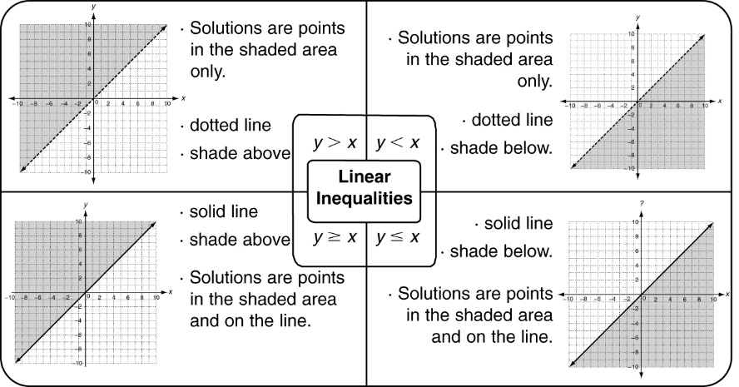
Reading Strategies 5.5
There are infinitely many solutions for linear inequalities. That’s why the solutions are shown as a graph on a coordinate plane. There are four possible ways to draw the line and shade the correct half plane. These correspond to the four inequality symbols >, ≥, <, ≤. Use the graphic aid below as a guide.

Tell whether the graph is a solid or dotted line, & whether the shading is above or below the line.
1. y ≤ x + 7 2. y > −5x 3. y ≥ 3x − 2

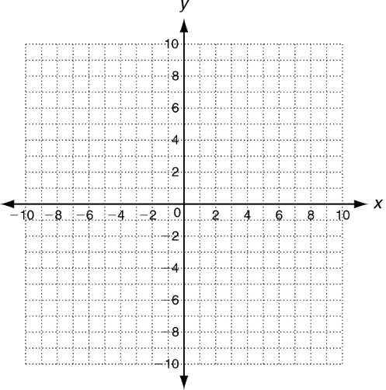
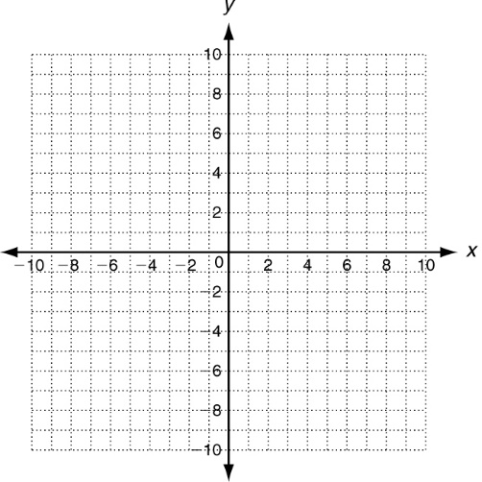
Graph each linear inequality. Name one point that is a solution, and one point that is not a solution.
4. y ≥ −x + 3 5. y < x + 5

____________ ____________

____________ ____________

Practice 5.5 A: Solving Linear Inequalities
Use substitution to tell whether the ordered pair is a solution of the given inequality.
1. (3, 4); y > x + 2 2. (4, 2); y ≤ 2x − 3 3. (2, −1); y < −x

Rewrite each linear inequality in slope-intercept form. Then graph the solutions.
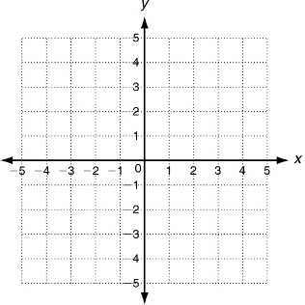
4. y − x ≤ 3 5. 6x + 2y > −2

_________________ _________________

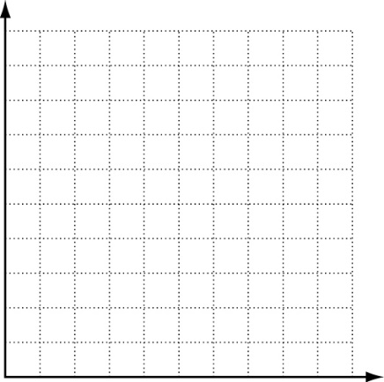
6. Trey is buying peach and blueberry yogurt cups. He will buy at most 8 cups of yogurt. Let x be the number of peach yogurt cups and y be the number of blueberry yogurt cups he buys.
a. Write an inequality to describe the situation.
_____________________________________
b. Graph the solutions.
c. Give two combinations of yogurt that he can choose.
______________________________________________________
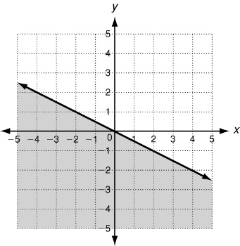
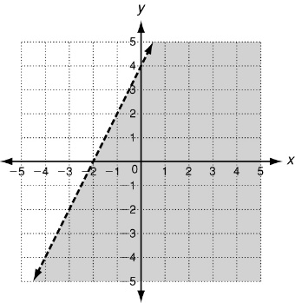
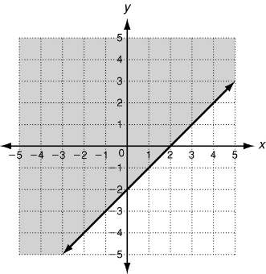
Write an inequality to represent each graph.
7. 8. 9.

