Name: __________________________________________________ Date: ___________________ Class:_______

**5.3 Introductory Worksheet (5.1-5.2 Review)**

Solve each system by graphing. Check your answer.

1. $\left\{\begin{aligned}y=x+1 \\ y=-x+5\end{aligned}\right.$ 2.

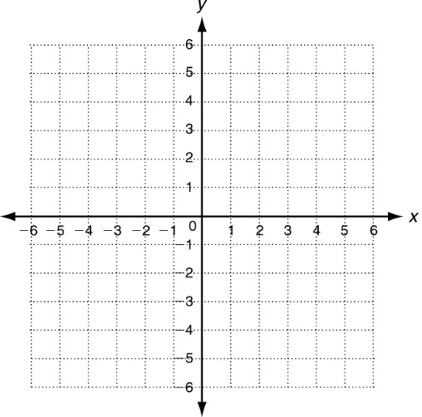



solution: _______ solution: _______

Solve each system by substitution. Check your answer.

1.  4. 

solution: _______ solution: _______

Solve each system by elimination. Check your answer.

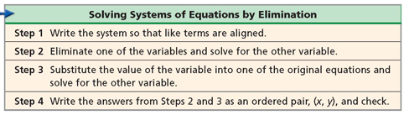

Example: 

**Step 1:** terms are already lined up

**Step 2:** eliminate y, by adding straight down then divided by 8 to solve to get $x=2$

**Step 3:** substitute 2 into the first equation and solve for $y=0$

**Step 4:** write as an ordered pair

+

$x=2$

$3\left(2\right)+y=6$

$6+y=6$

$y=0$

$(2,0)$

1. $\left\{\begin{aligned}-x+y=1 \\ x+y=3\end{aligned}\right.$ 6. $\left\{\begin{aligned}x-y=-3 \\ 2x+y=0\end{aligned}\right.$

solution: _______ solution: _______

1.  8. 

solution: _______ solution:

$\left\{\begin{aligned}-2x-y=-5 \\ 3x+y=-1\end{aligned}\right.$ _______

1. 10. $\left\{\begin{aligned}x+y=3 \\ 2x-y=6\end{aligned}\right.$

solution: _______ solution:

$\left\{\begin{aligned}2x+5y=9 \\ -2x+6y=-20\end{aligned}\right.$ _______

1. 12. $\left\{\begin{aligned}6x-2y=4 \\ -8x+2y=4\end{aligned}\right.$

solution: _______ solution: _______