4.6 Practice A
4-6 Slope-Intercept Form
Write the equation that describes each line in slope-intercept form.

1. slope = 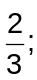 y-intercept = 2
y = ______ x + ______
2. slope = −1; y-intercept = −8
y = ______ x − ______
3. slope = −2; (3, 5) is on the line.
Find the y-intercept: y = mx + b
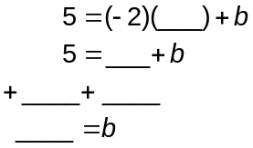
Write the equation: y = ______ x + ______

Write each equation in slope-intercept form. Then graph the line.
4. y − 2x = −4 5. y − 3 = −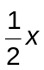 6. 2x + 3y = 6

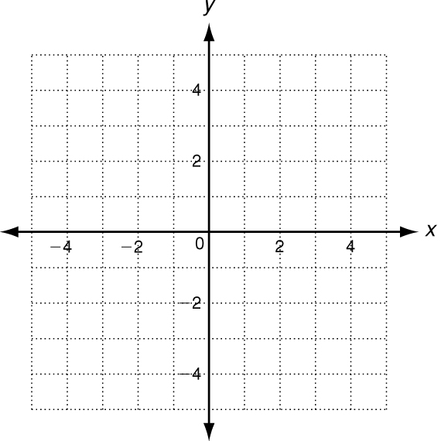
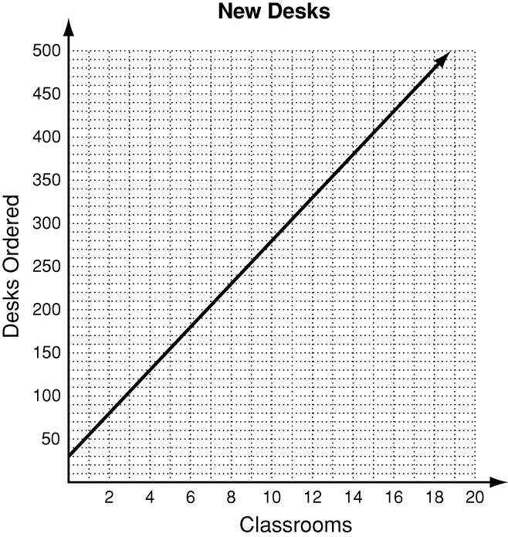
7. A school orders 25 desks for each classroom,
plus 30 spare desks. The total number ordered
as a function of the number of classrooms is shown
in the graph.
a. Write the equation represented by the graph.

b. Identify the slope and y-intercept and describe their
meanings. ________________________________________

c. Find the total number of desks ordered if there are
24 classrooms.

4.6 Practice B
4-6 Slope-Intercept Form
Write the equation that describes each line in slope-intercept form.

1. slope = 4; y-intercept = −3
y = _______________________
2. slope = −2; y-intercept = 0
y = _______________________
3. slope = 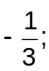 y-intercept = 6
y = _______________________
4. slope = 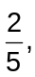 (10, 3) is on the line.
Find the y-intercept y = mx + b
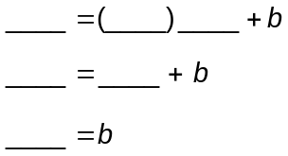
Write the equation: y = ______________

Write each equation in slope-intercept form. Then graph the line described by the equation.
5. y + x = 3 6. y + 4 = 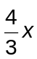 7. 5x − 2y = 10

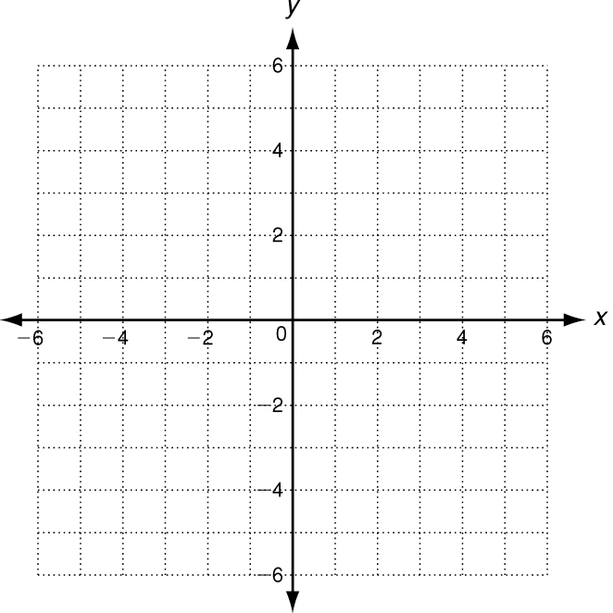
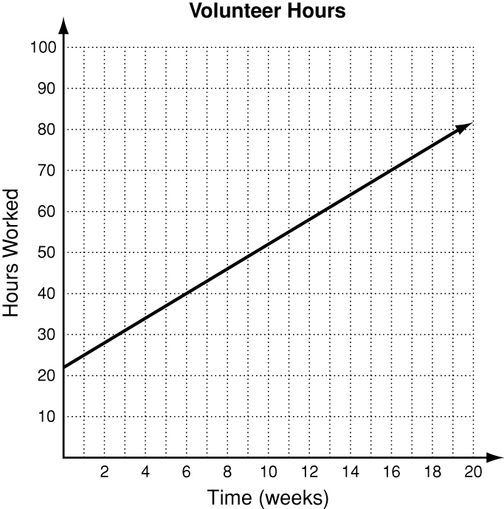
8. Daniel works as a volunteer in a homeless shelter.
So far, he has worked 22 hours, and he plans to
continue working 3 hours per week. His hours worked
as a function of time is shown in the graph.
a. Write an equation that represents the hours Daniel
will work as a function of time. _____________________
b. Identify the slope and y-intercept and describe their
meanings. ________________________________________

c. Find the number of hours worked after 16 weeks.

