Name Date Class
Practice 4.10: Transforming Linear Functions
Fill in each blank with translation, rotation, or reflection.

1.A __________________________________ is like a turn. 2. A __________________________________ is like a slide.

3. A __________________________________ is like a flip.

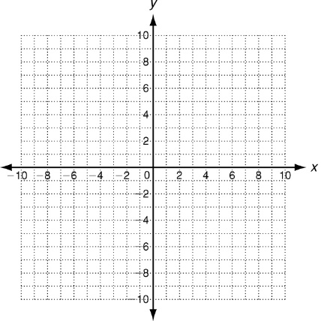
Graph f(x) and g(x). Then describe the transformation(s) from the graph of f(x) to the graph of g(x).
- f(x) = x + 5; g(x) = −x + 5

- f(x) = 2x − 4; g(x) = -2x + 4

- f(x) = 2x − 4; g(x) = 2x + 3

- f(x) = 2x − 1; g(x) = 4x − 1

- f(x) = x; g(x) = 2x − 5

8. The cost of making a ceramic picture frame at a paint-your-own pottery store is $12, plus $5 per
hour while you paint. The total cost for the frame that you spend x hours painting is f(x) = 5x + 12.
a. How will the graph of this function change if the cost of the frame is raised to $15?

b. How will the graph of this function change if the hourly charge is lowered to $4?

Review for Mastery: Transforming Linear Functions
Describe the transformations from the graph of f(x) to the graph of g(x).

10. f(x) = x; g(x) =

11. f(x) = x; g(x) = x − 5

12. f(x) = x; g(x) = 6x

13. f(x) = 6x; g(x) = −6x

Each function below is reflected across the y-axis. Write a function h(x) to describe each new graph.
14. f(x) = 5x 15. f(x) = −9x 16. f(x) = 2x + 7

Describe the transformations from the graph of f(x) to the graph of g(x).

- f(x) = x, g(x) = 4x − 2

- f(x) = x, g(x) = 0.25x + 3

- f(x) = 2x, g(x) = x + 8

- f(x) = −5x, g(x) = x

- The cost of hosting a party at a horse farm is a flat fee of $250, plus $5 per person. The total charge for a party of x people is f(x) = 5x + 250.
How will the graph of this function change if the flat fee is lowered to $200?

How will the graph of this function change if the per-person rate is raised to $8?

