4.3 Practice A
Rate of Change and Slope
Fill in the blanks to define slope.
1. The ___________ is the difference in the y-values of two points on a line.
2. The ___________ is the difference in the x-values of two points on a line.
3. The slope of a line is the ratio of ___________ to ___________ for any two points on the line.
Find the rise and run between each set of points. Then, write the slope of the line.
4. 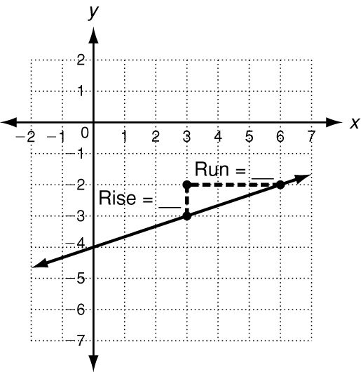 5. 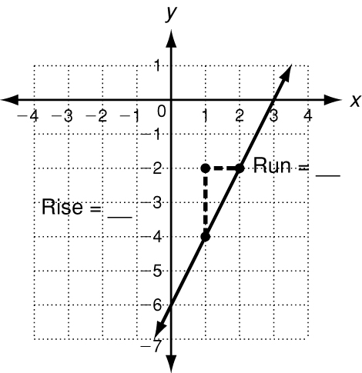 6. 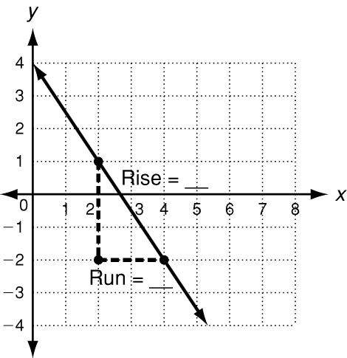
slope = _______________ slope = _______________ slope = _______________
Tell whether the slope of each line is positive, negative, zero, or undefined.
7. 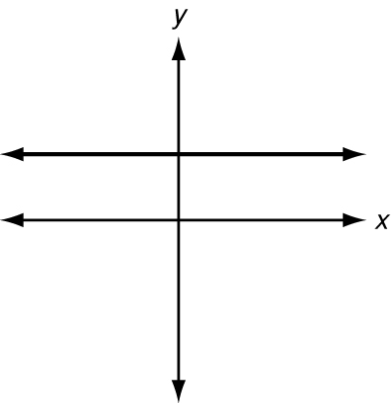 8.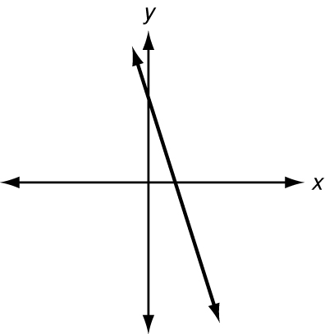 9. 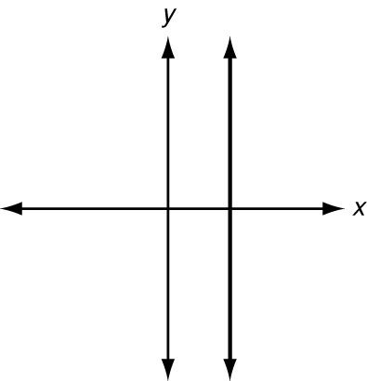

10. The table shows a truck driver’s distance from home during one day’s
deliveries. Find the rate of change for each time interval.
Time (h) | 0 | 1 | 4 | 5 | 8 | 10
Distance (mi) | 0 | 35 | 71 | 82 | 199 | 200
Hour 0 to Hour 1: _________ Hour 1 to Hour 4: _________ Hour 4 to Hour 5: _________
Hour 5 to Hour 8: _________ Hour 8 to Hour 10: _________
The rate of change represents the average speed. During which time interval
was the driver’s average speed the least? _________________________________

4.3 Practice B
Rate of Change and Slope
Find the rise and run between each set of points. Then, write the slope of the line.
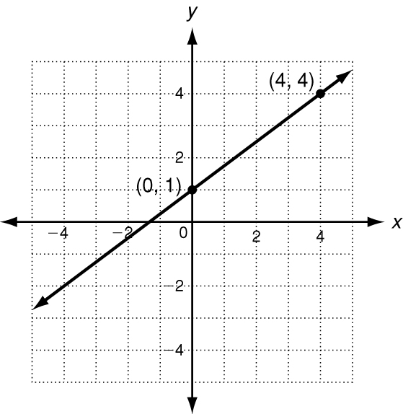
1. 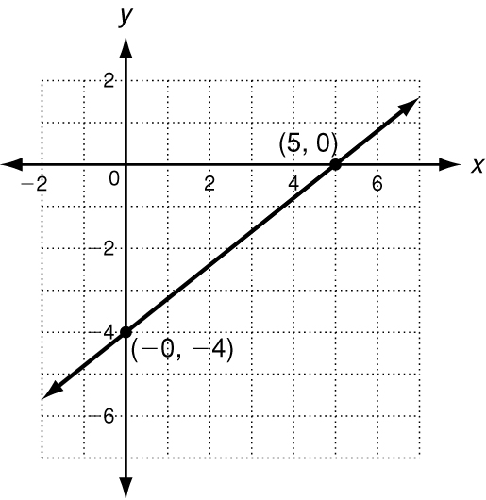 2. 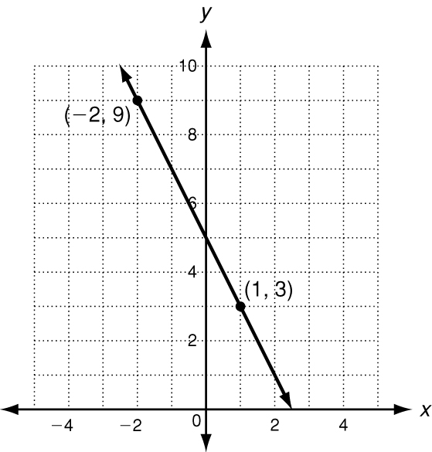 3.
rise = ______ run = ______ rise = ______ run = ______ rise = ______ run = ______
slope = _______________ slope = _______________ slope = _______________
4. 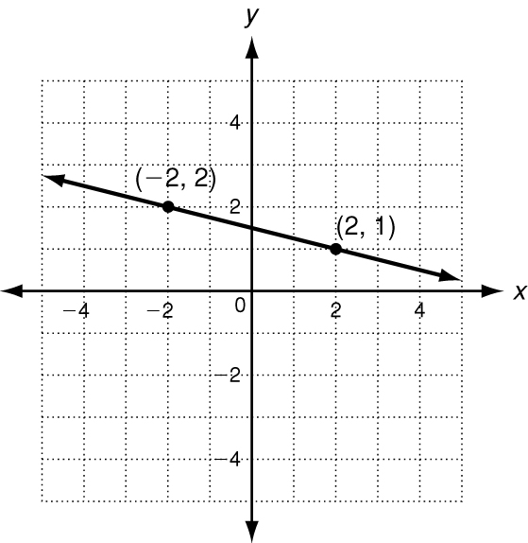 5. 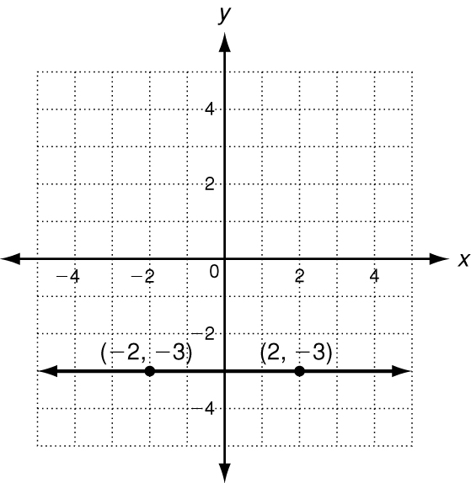 6. 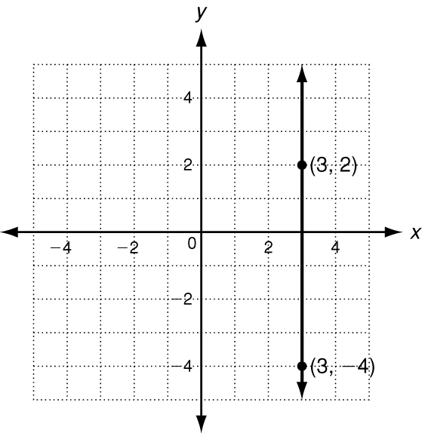
rise = ______ run = ______ rise = ______ run = ______ rise = ______ run = ______
slope = _______________ slope = _______________ slope = _______________
Tell whether the slope of each line is positive, negative, zero, or undefined.
7. 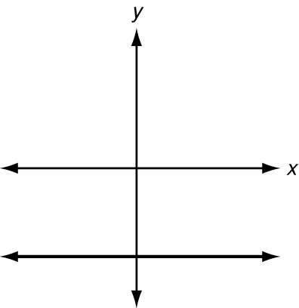 8. 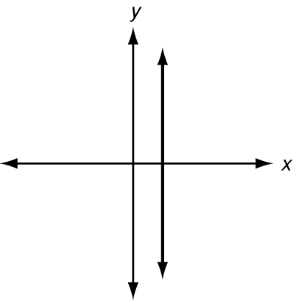 9. 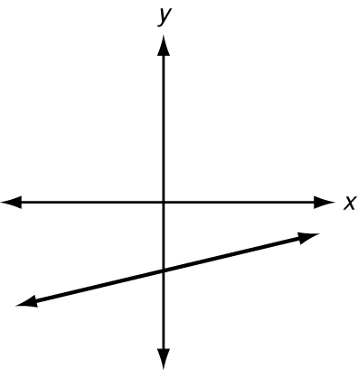

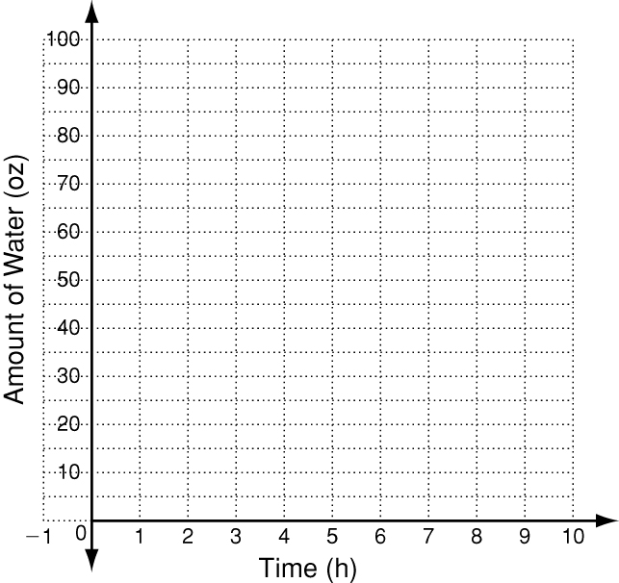
10. The table shows the amount of water in a
pitcher at different times. Graph the data and
show the rates of change. Between which two
hours is the rate of change the greatest? _______________
Time (h) | 0 | 1 | 2 | 3 | 4 | 5 | 6 | 7
Amount (oz) | 60 | 50 | 25 | 80 | 65 | 65 | 65 | 50

