4.1 Practice A
Identifying Linear Functions
Use the graph for 1–3.
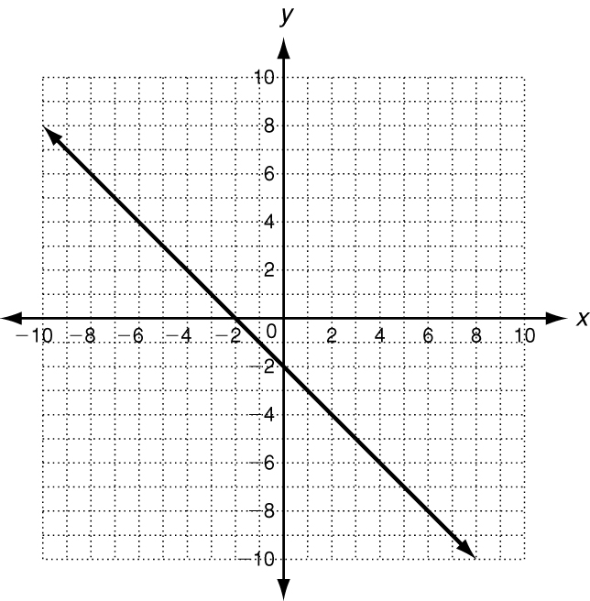
1. Is this graph a function?
2. Explain how you know it is a function.

3. If this graph is a function, is it also
a linear function?

Use the set {(1, 8), (2, 6), (3, 4), (4, 2), (5, 0)} for 4–5.
4. Does the set of ordered pairs satisfy a linear function?
5. Explain how you decided.

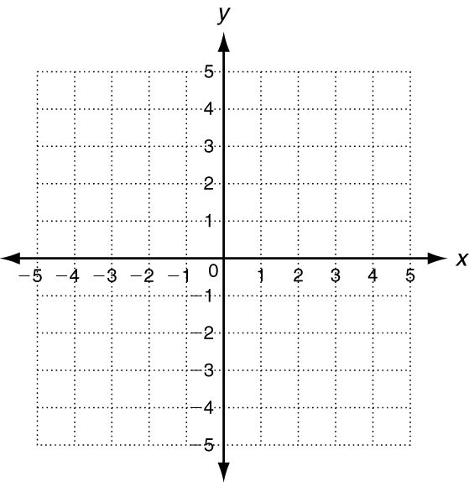
6. Write the equation y = x − 4 in standard
form (Ax + By = C).

7. Is y = x − 4 a linear function?

8. Graph y = x − 4 to check.

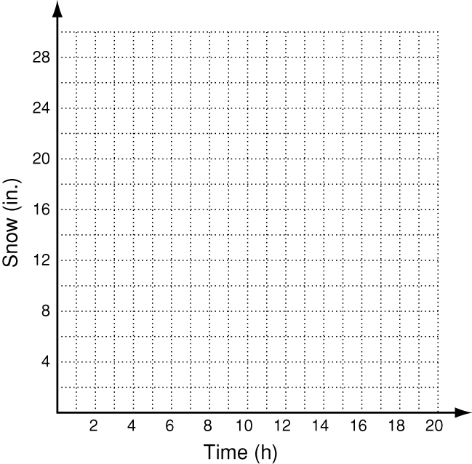
9. In 2005, a storm in Milwaukee, WI was dropping 2.5
inches of snow every hour. The total amount of snow
is given by f(x) = 2.5x, where x is the number of hours.
Graph this function and give its domain and range.

4.1 Practice B
Identifying Linear Functions
Identify whether each graph represents a function. Explain. If the graph does represent a function, is the function linear?
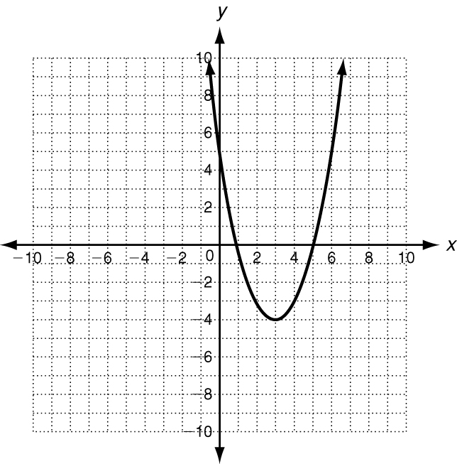

1.

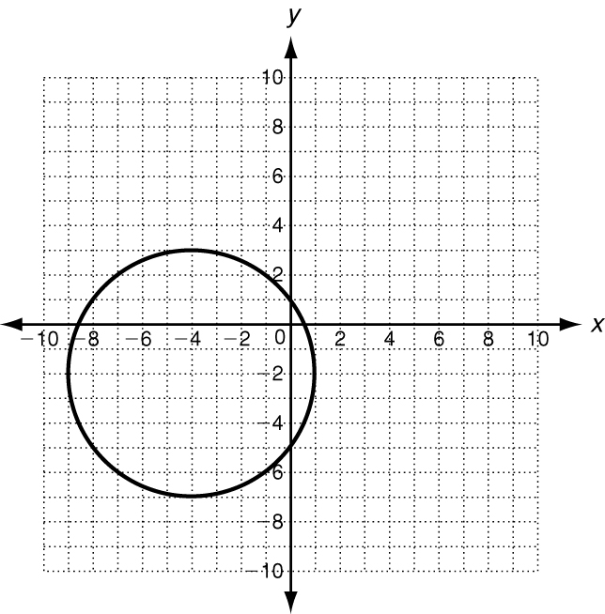

2.

3. Which set of ordered pairs satisfies a linear function? Explain.
Set A: {(5, 1), (4, 4), (3, 9), (2, 16), (1, 25)}
Set B: {(1, −5), (2, −3), (3, −1), (4, 1), (5, 3)}
4. Write y = −2x in standard form. Then graph the function.

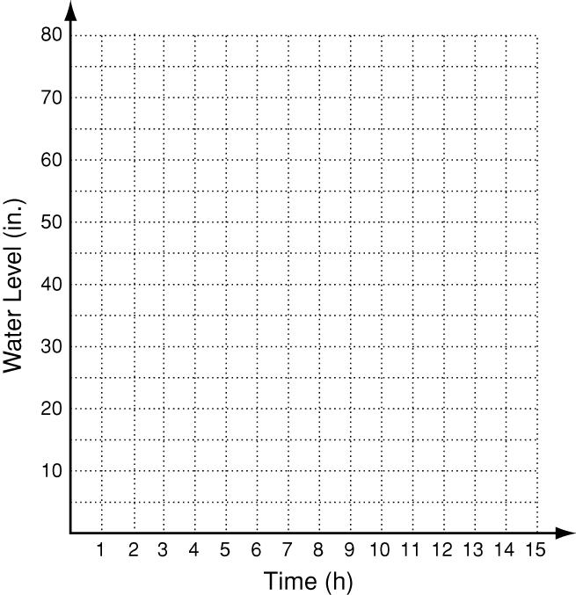
5. In 2005, the Shabelle River in Somalia rose an
estimated 5.25 inches every hour for 15 hours. The
increase in water level is represented by the function
f(x) = 5.25x, where x is the number of hours. Graph
this function and give its domain and range.

